Application Deployment guide

Contents

1 Introduction 2

1.1 Purpose 2

2 Components 2

2.1 EDS 2

2.1.1 EDS war creation in DMS 2

2.1.2 Database Tables Required : 3

2.2 FDM Artifacts 4

2.2.1 DMS Class 4

2.2.2 Entry Template for DMS class 5

2.2.3 Search Template for DMS 9

2.3 PCC-Configuration 12

2.3.1 Components Creation : 12

2.3.2 Property File Path: 19

2.3.3 In-basket Details. 19

2.3.4 Work Queues 19

2.3.5 In-baskets 21

2.3.6 Roles 22

2.4 Security Proxy 25

2.5 Workflow Subscription 29

2.6 CE Properties 36

2.7 Desktop Creation 37

2.8 Reports 39

# Introduction

## Purpose

The purpose of this document is to provide instructions for DMS build deployment into FileNet environment.

# Components

## EDS

### EDS war creation in DMS

As EDS War already deployed please add below .class files in path and property file.

1. Modified “ObjectTypes.json” file included below code

{"symbolicName": "Edelwesis"},

{"symbolicName": "DMS"},

{"symbolicName": "EdelweissDMS.Workflow.Dispatch"},

{"symbolicName": "EdelweissDMS.Workflow.Archival"}

2.Modified Util.properties file with included below code.

DMS_CLSSES = DMS, EdelweissDMS.Workflow.Dispatch,EdelweissDMS.Workflow.Archival

WorkFlowMandartoryClasses = EdelweissDMS.Workflow.Dispatch,EdelweissDMS.Workflow.Archival

3. Included below class names in EDS.

1. EDS_JSONPropCreat
2. SbuDTO
3. LobDTO
4. ProductDTO
5. RecordMasterDTO
6. ReadProperty

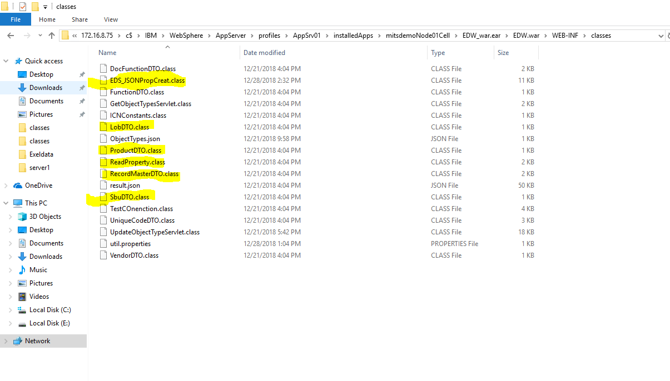

### Database Tables Required :

1. SBU
2. LOB
3. PRODUCT
4. RECORDMASTER
5. ENTITY

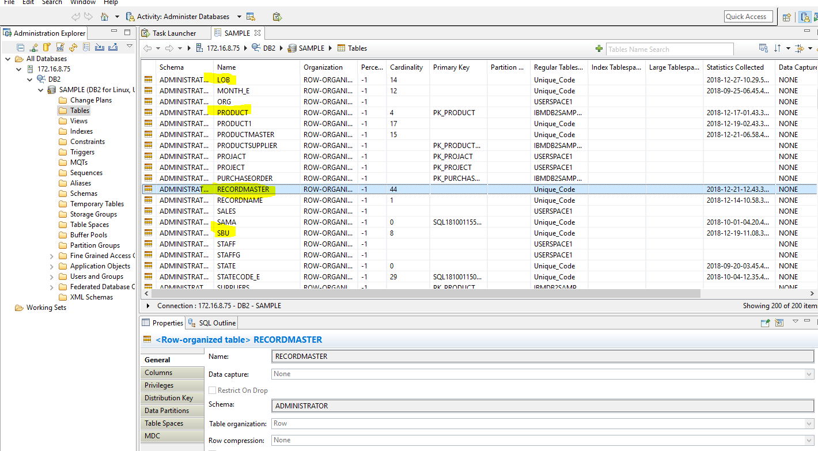

## FDM Artifacts

### DMS Class

1.Created Document class name with “**DMS**” and Workflow name with ‘**EdelweissDMS**’ .

To create a documents class follow the below steps.

* Open **Administration console for content engine** and go to document class, select new class as below.

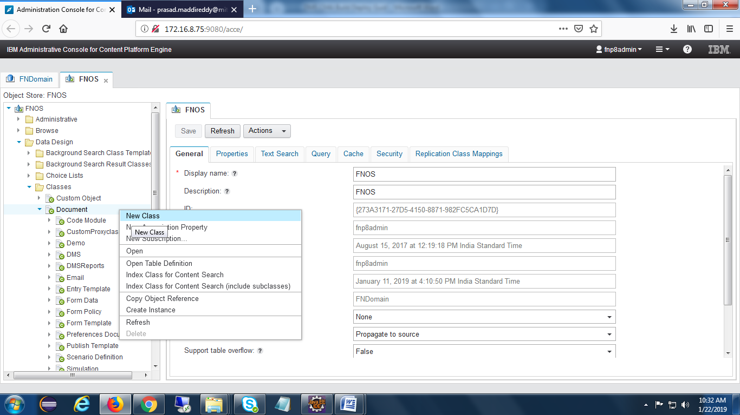

Provide name of the class ,then click on next and finish buttons.

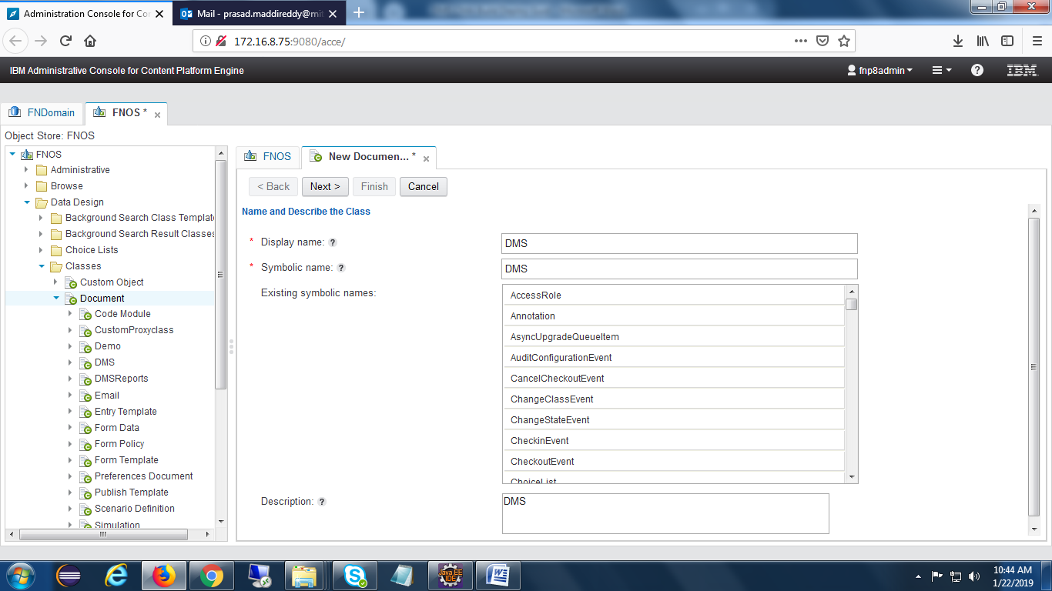

### Entry Template for DMS class

Open Navigator desktop and select **Open Entry Template View** feature.

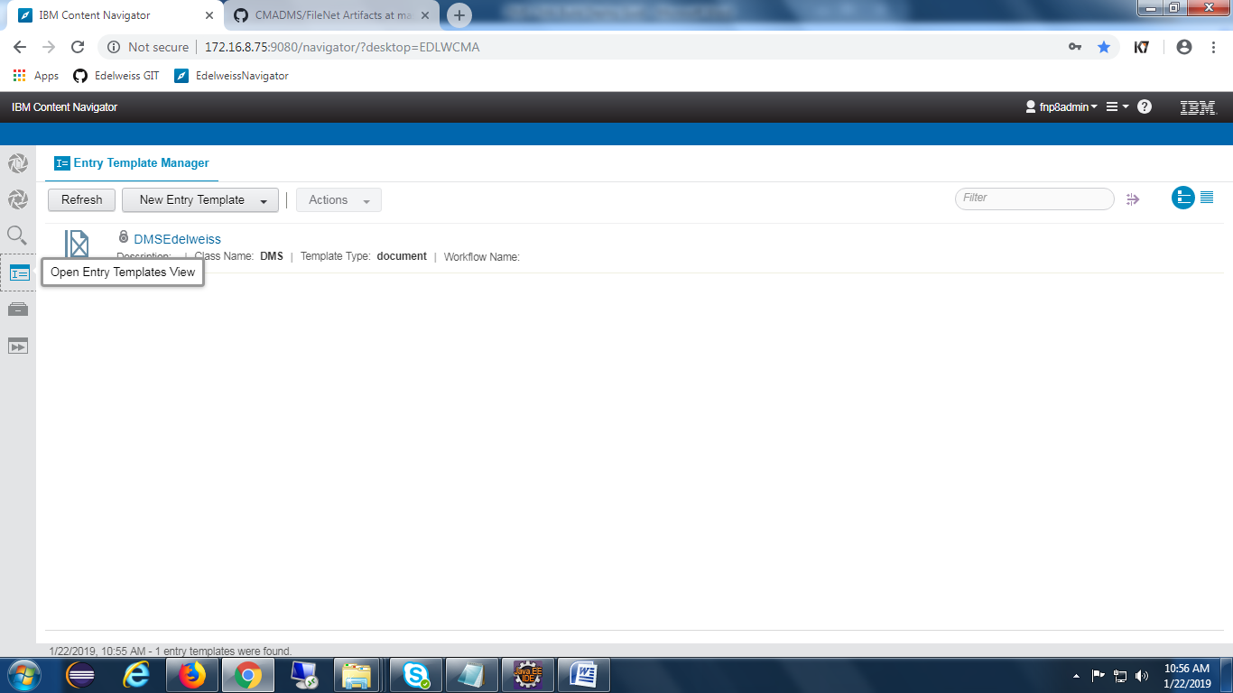

Click on New Entry Template Button and select document entry template as shown in the below screen.

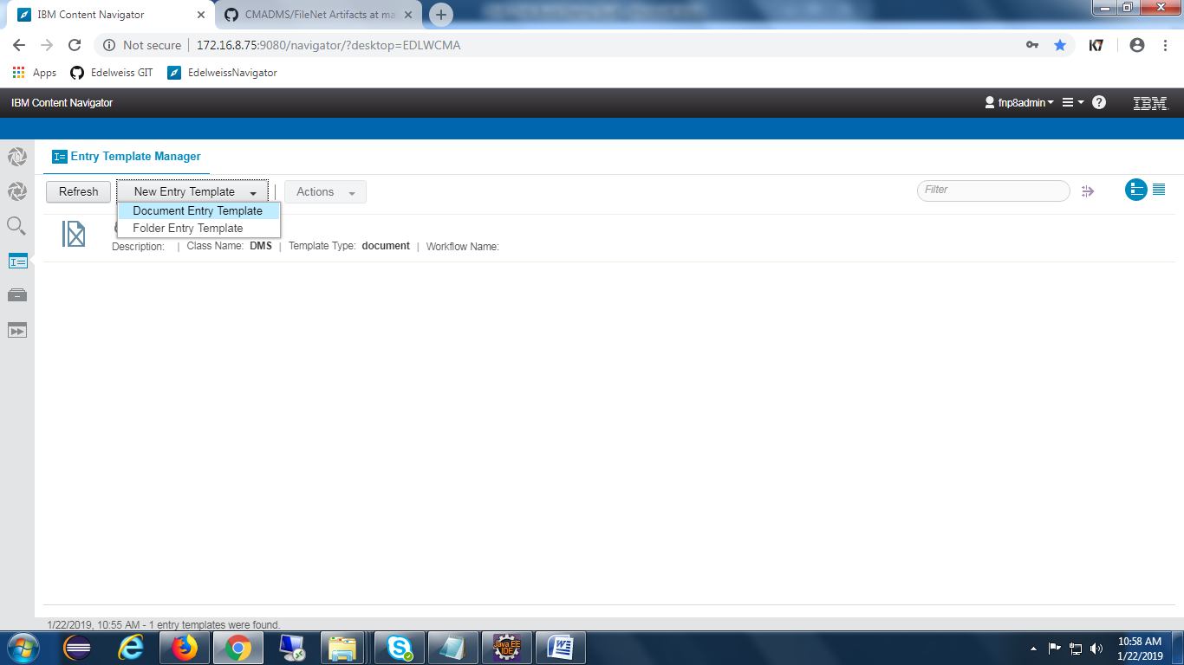

After selection of Document Entry Template below screen will appear.

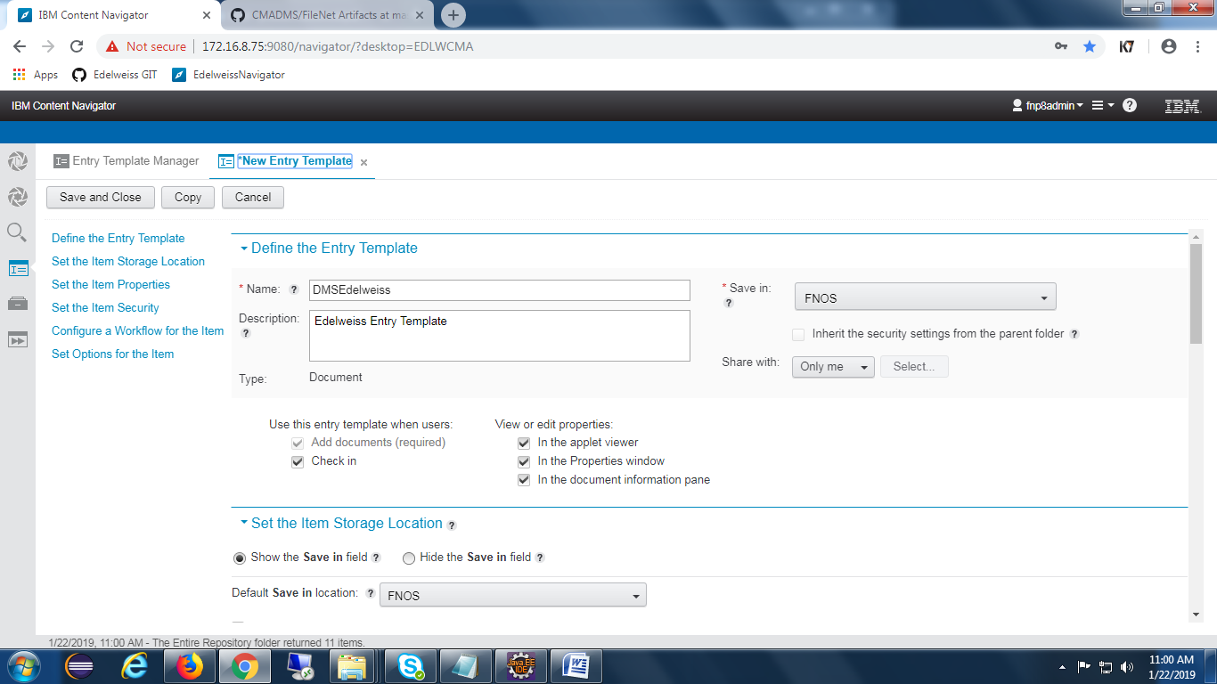

Click on edit layout and add all the required properties as below.

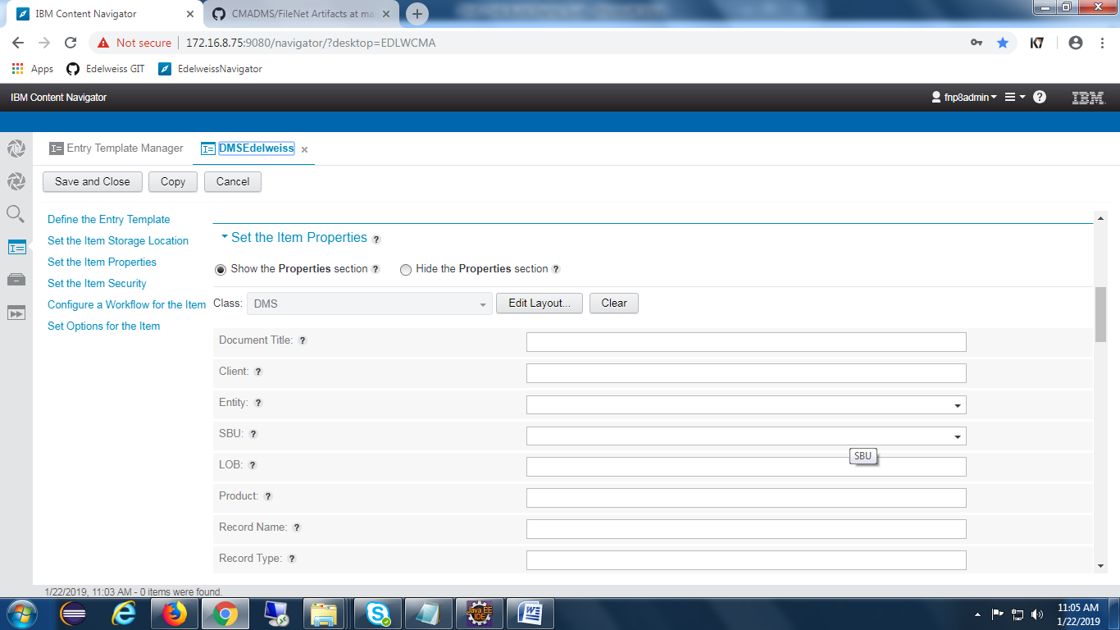

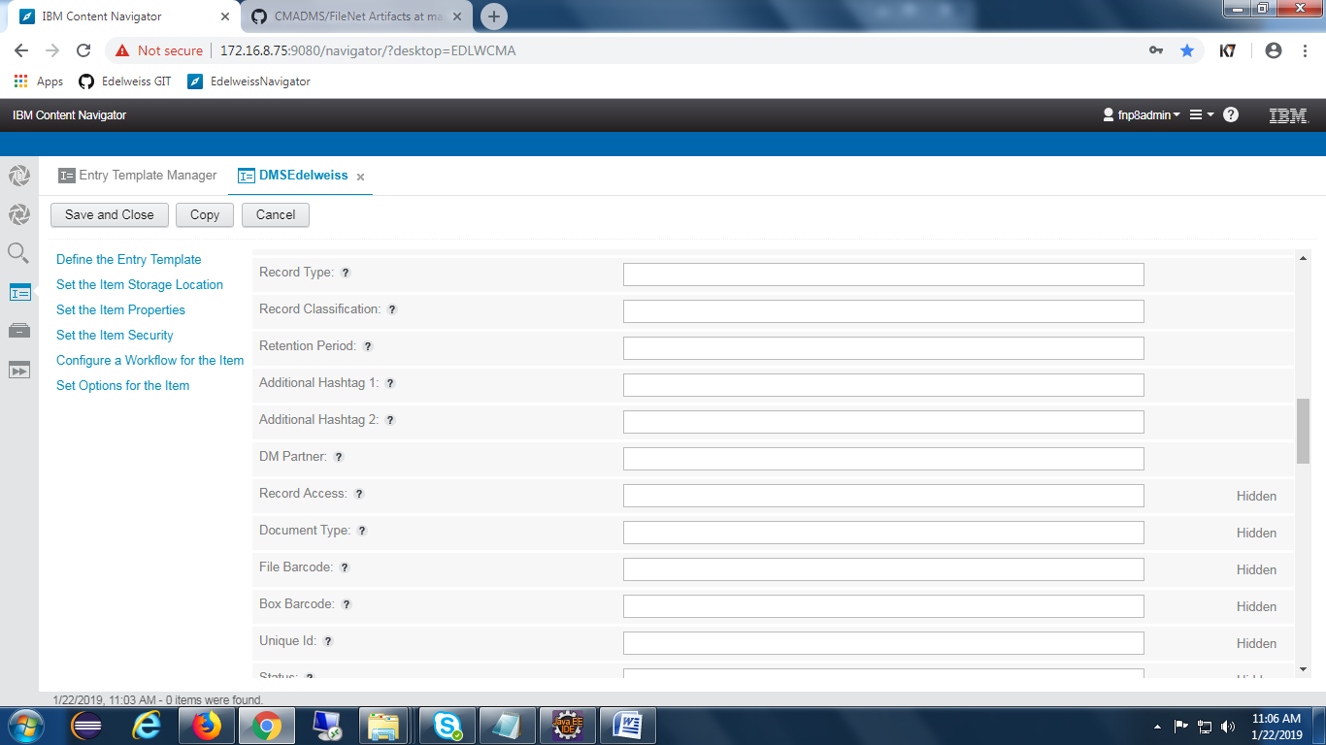

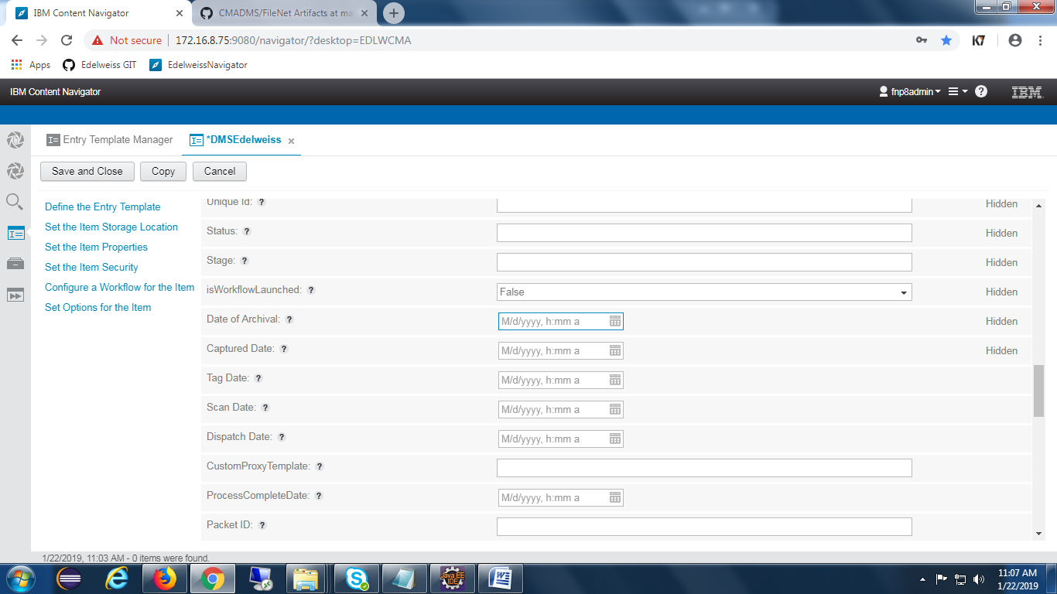

Provide security at the set item security tab, as shown in the below screen.

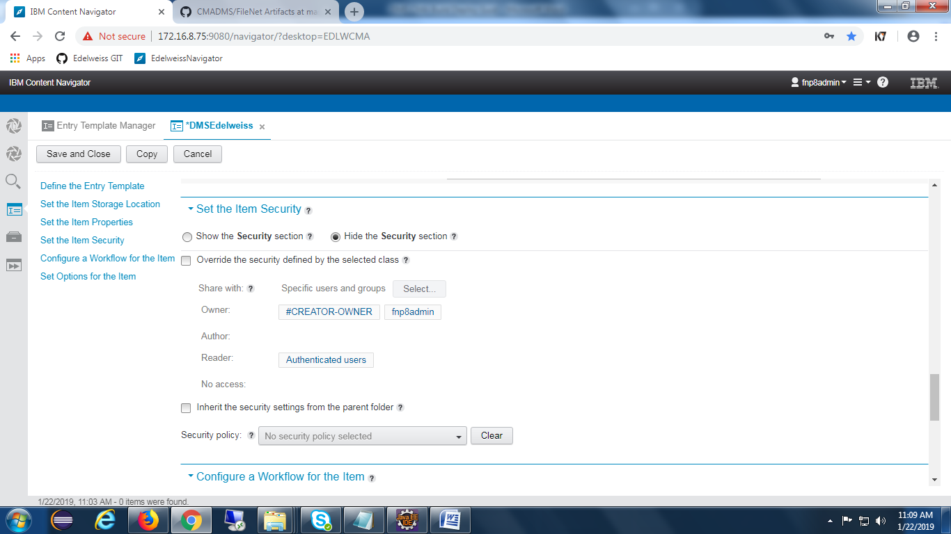

Click on Save and Close button to complete the creation of Entry template.

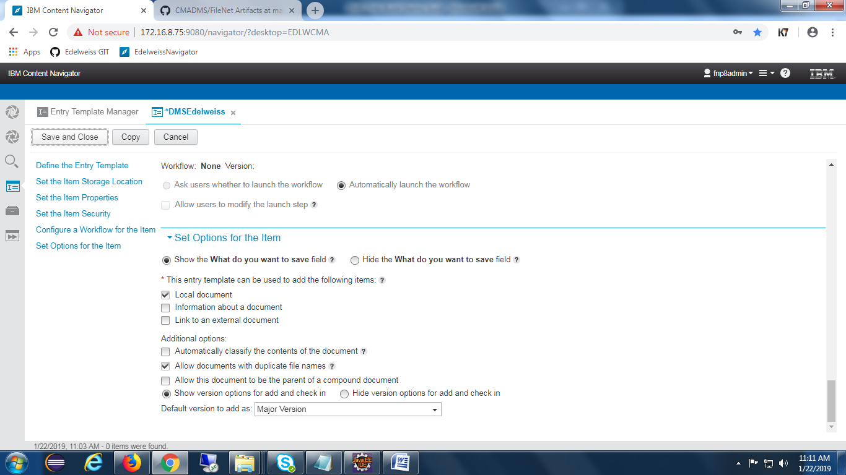

Once creation of entry template is completed , It will appear at Open Entry Template View feature as shown the below screen.

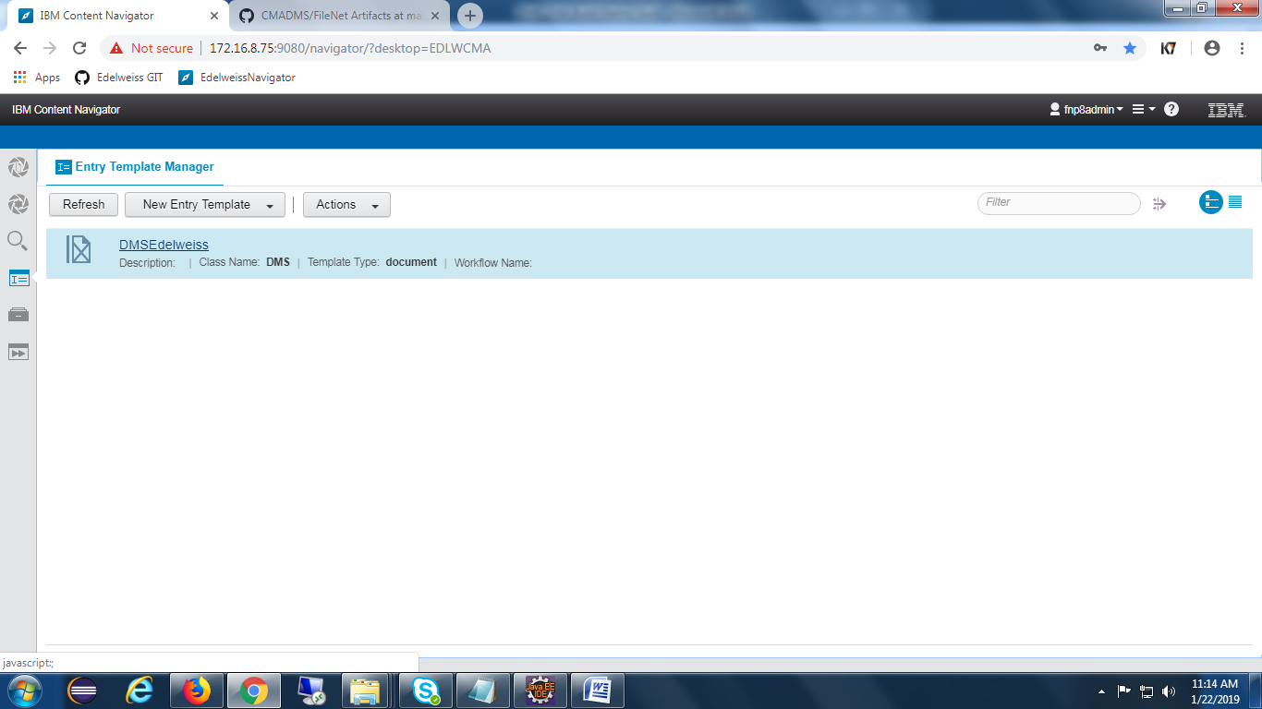

### Search Template for DMS

Open Navigator and click on **Open Search View** feature as shown in the below screen.

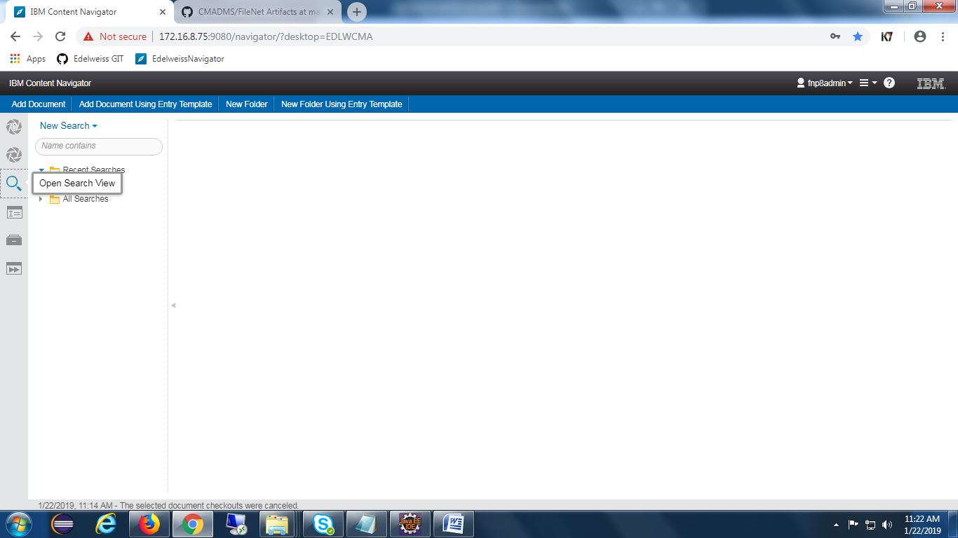

Click on New Search and add all the required search fields as shown in the below screen.

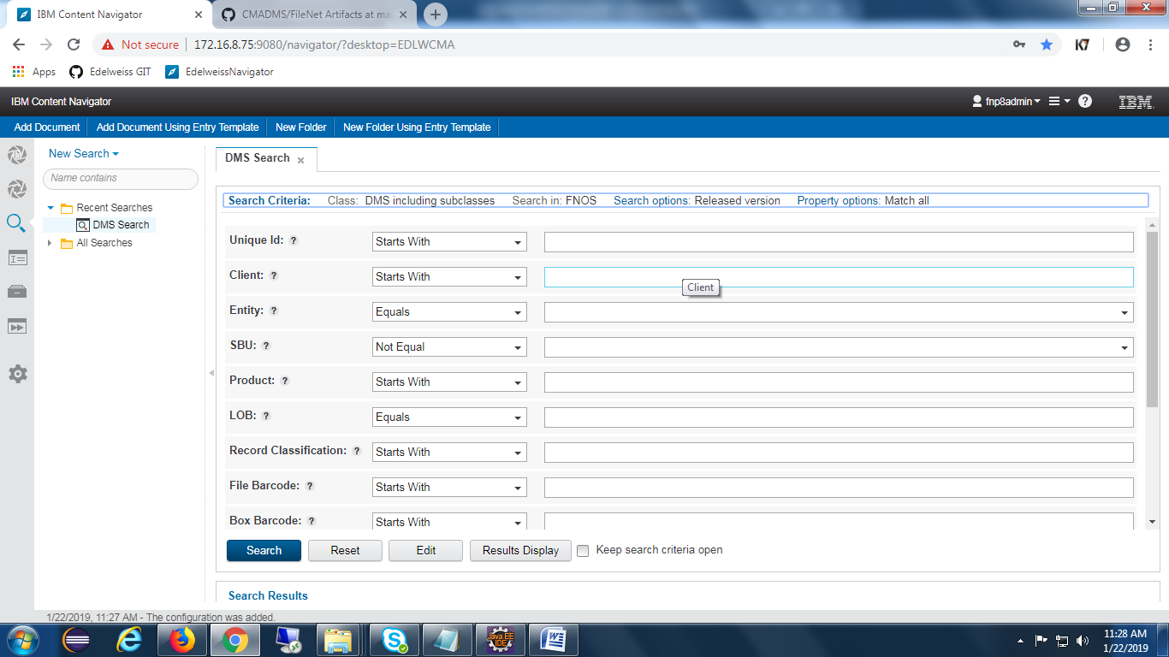

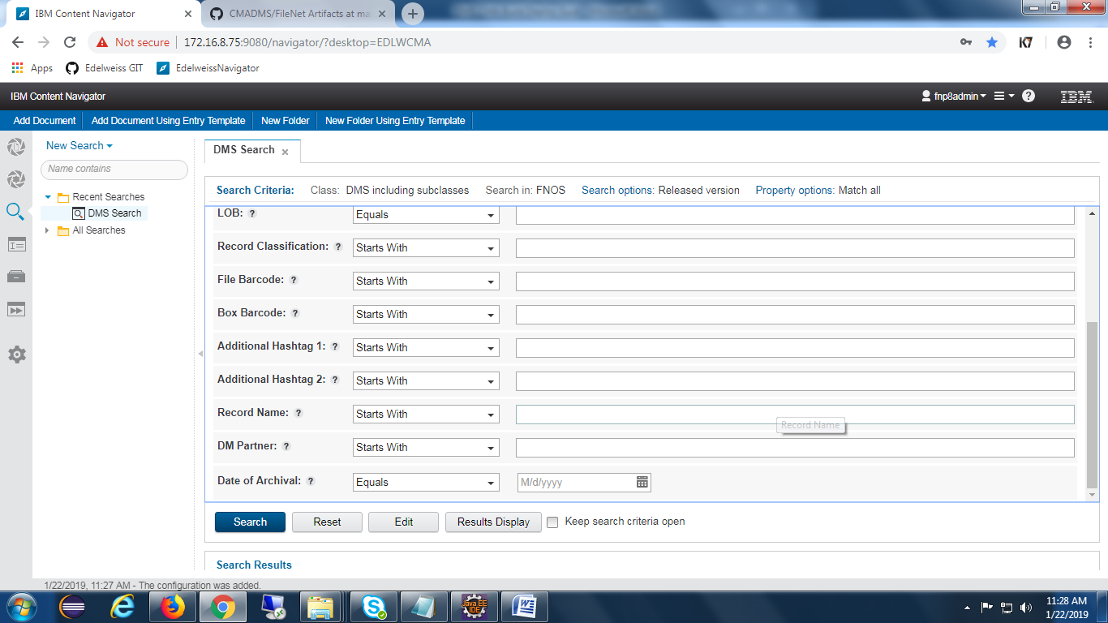

Click on Results Display button and add properties like below.

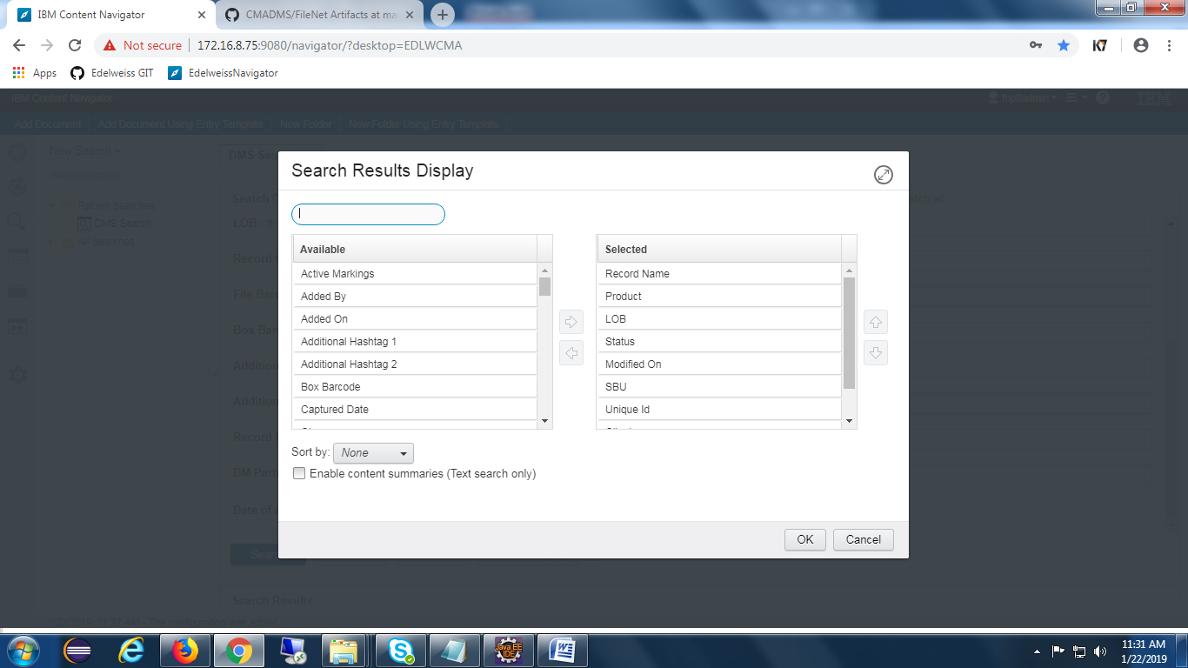

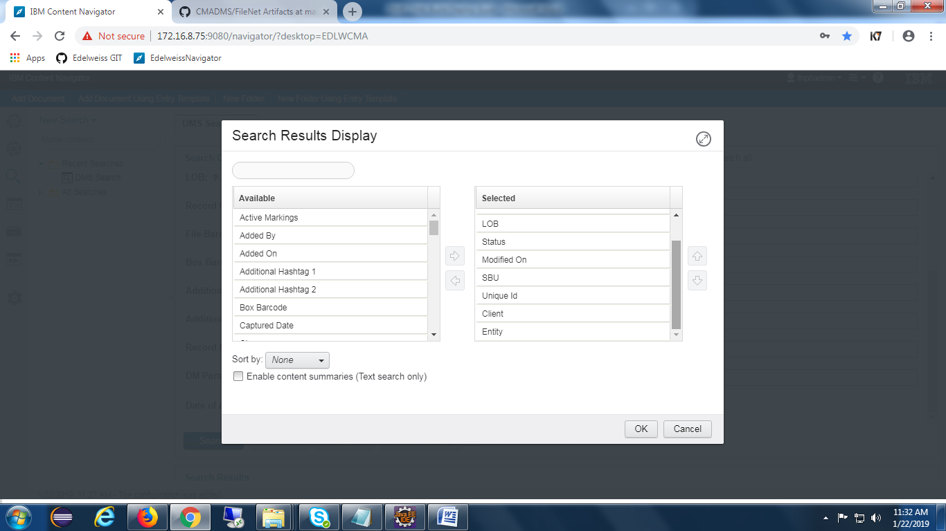

## PCC-Configuration

### Components Creation :

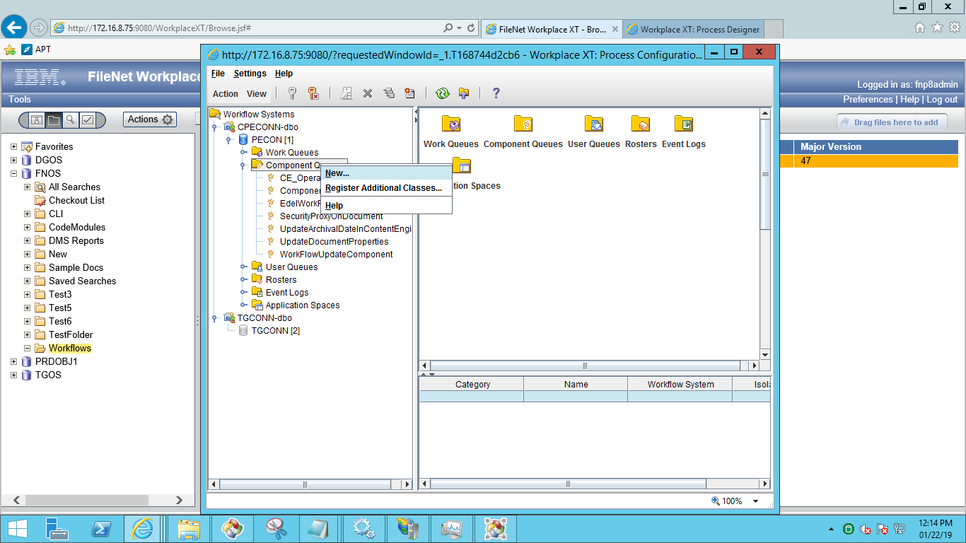

Provide appropriate Queue name as shown in the below screen and click on next button.

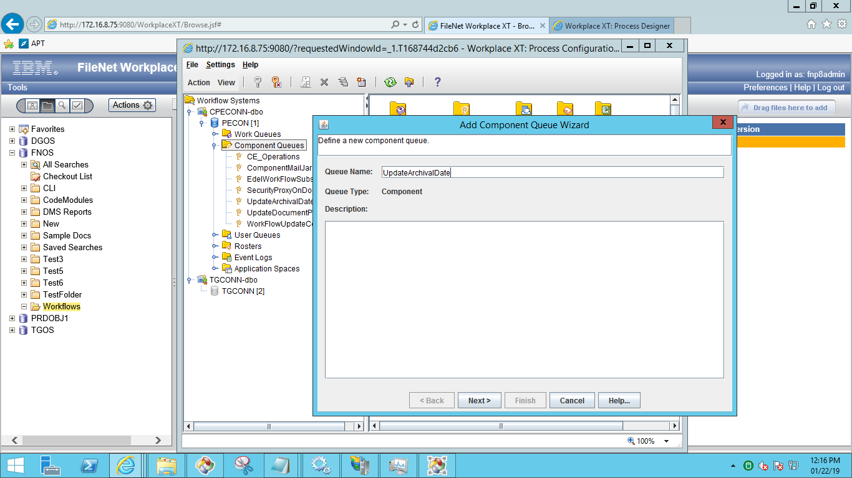

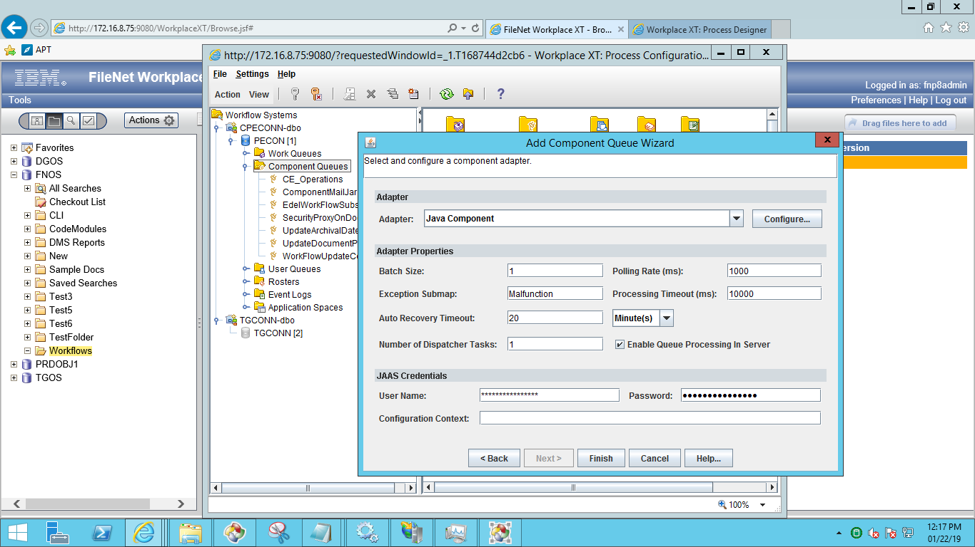

click on configure and select code module and class name of the component.

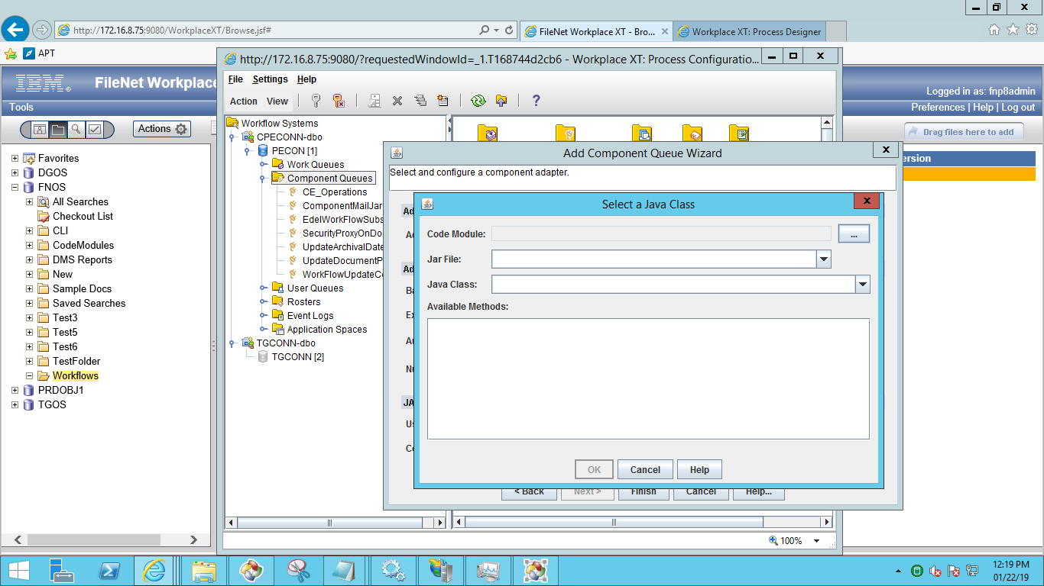

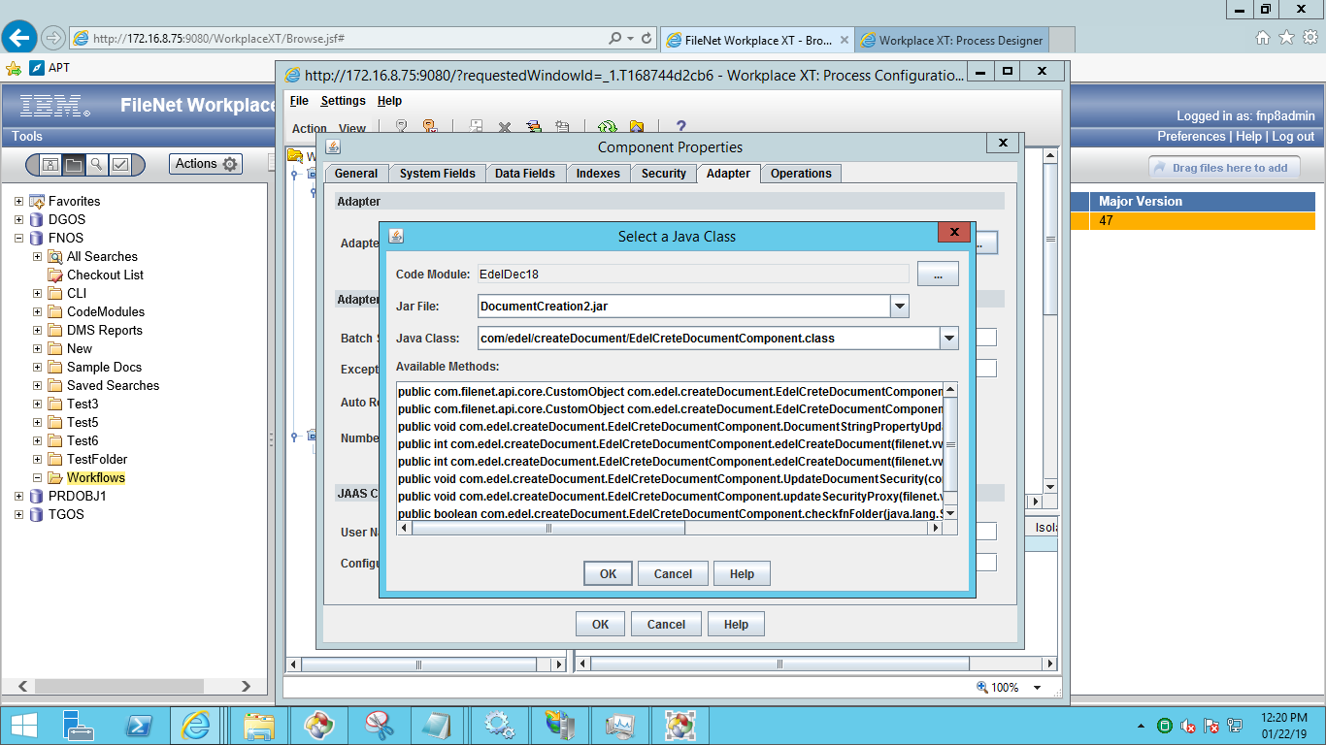

Click on OK button and go to properties tab and expose all the methods in it as shown in the below screen.

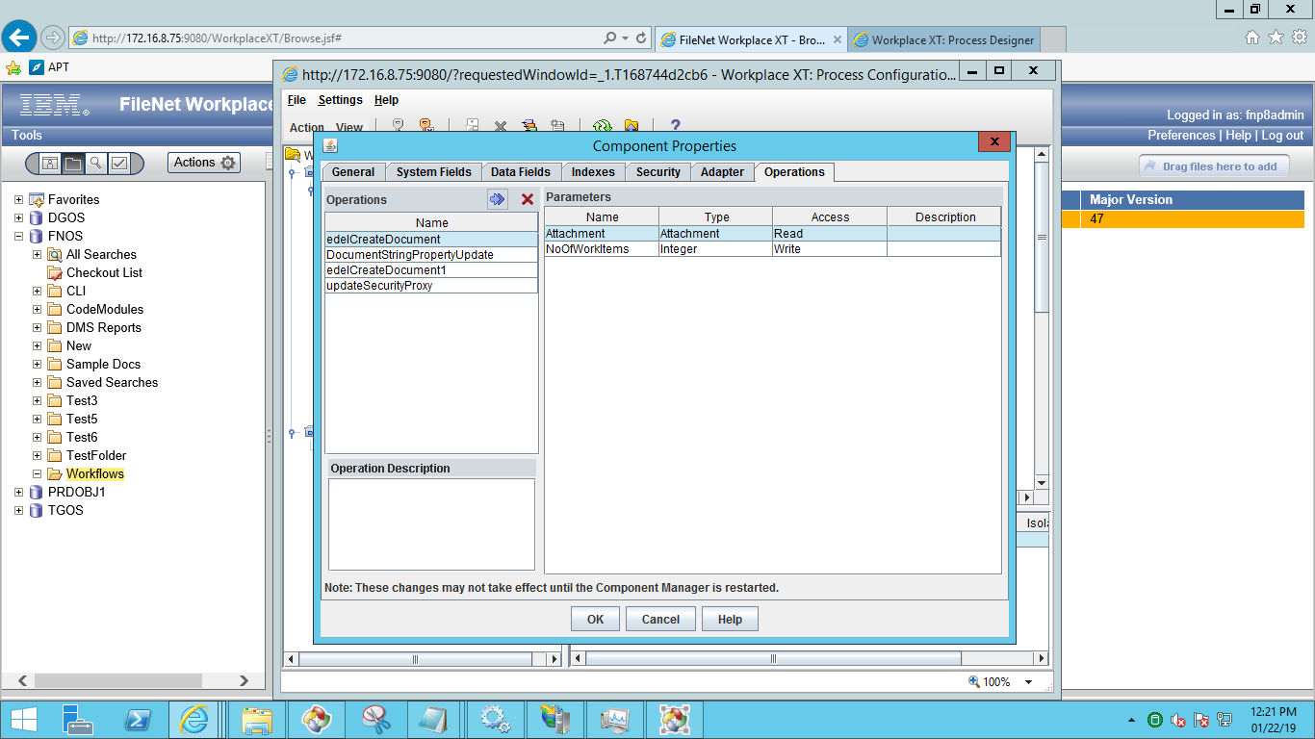

1. Workflowupdatecomponent

It helps the system to create a new version if the Client and Product is same.

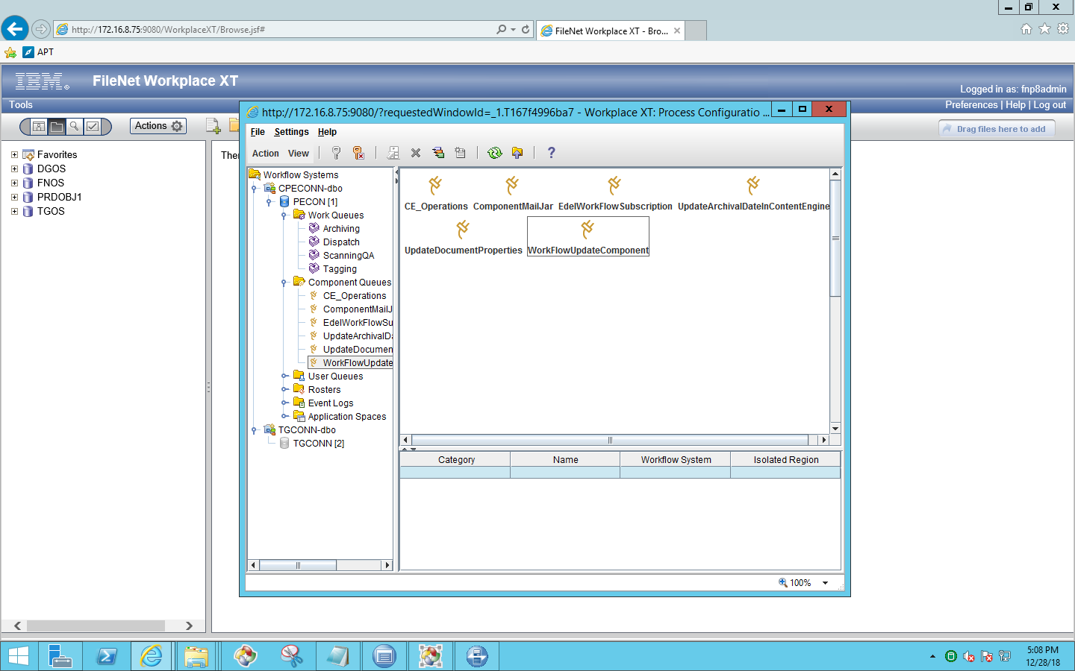

Click on adopter , then we will find below screen

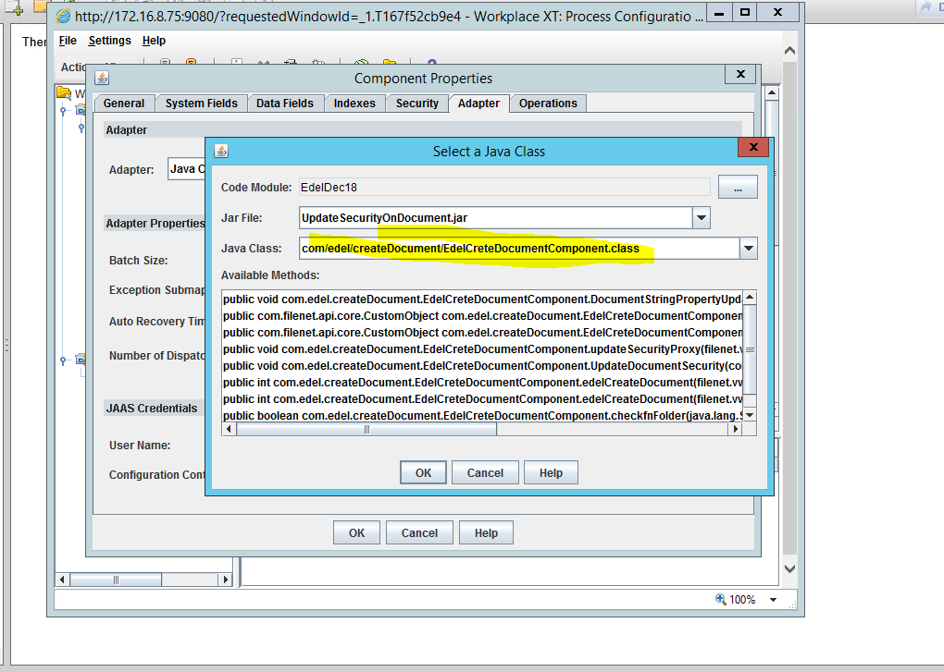

Click on properties , then we will find below screen

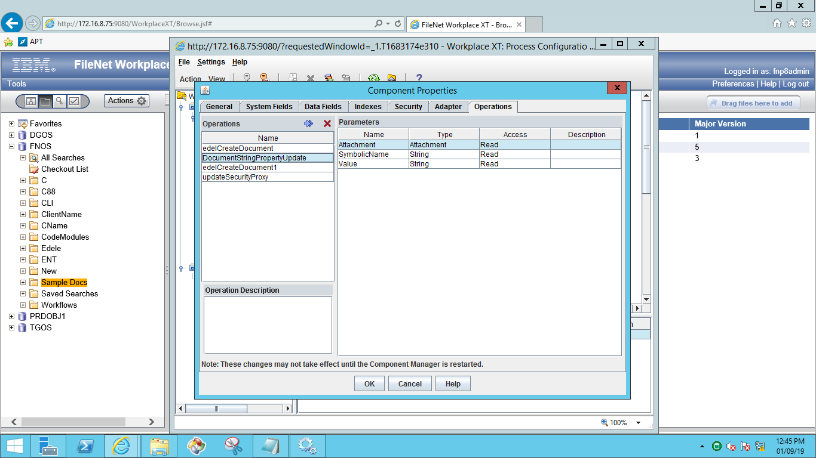

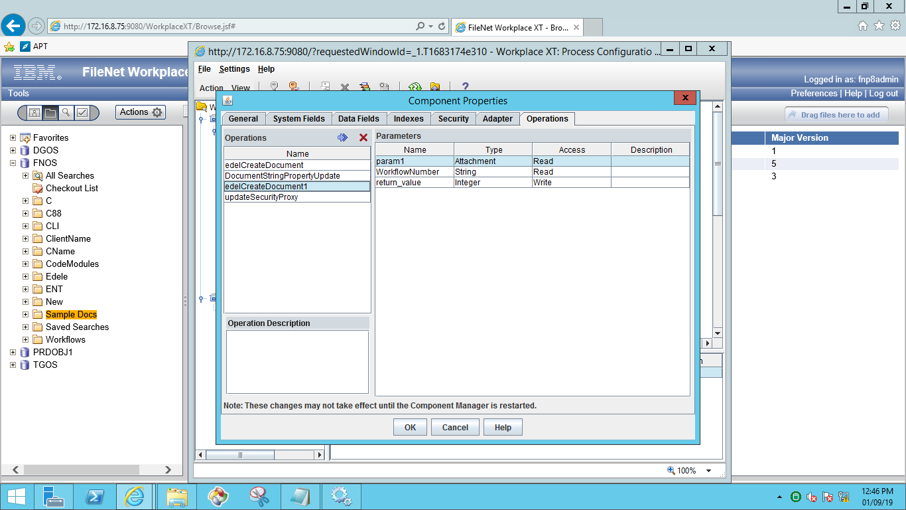

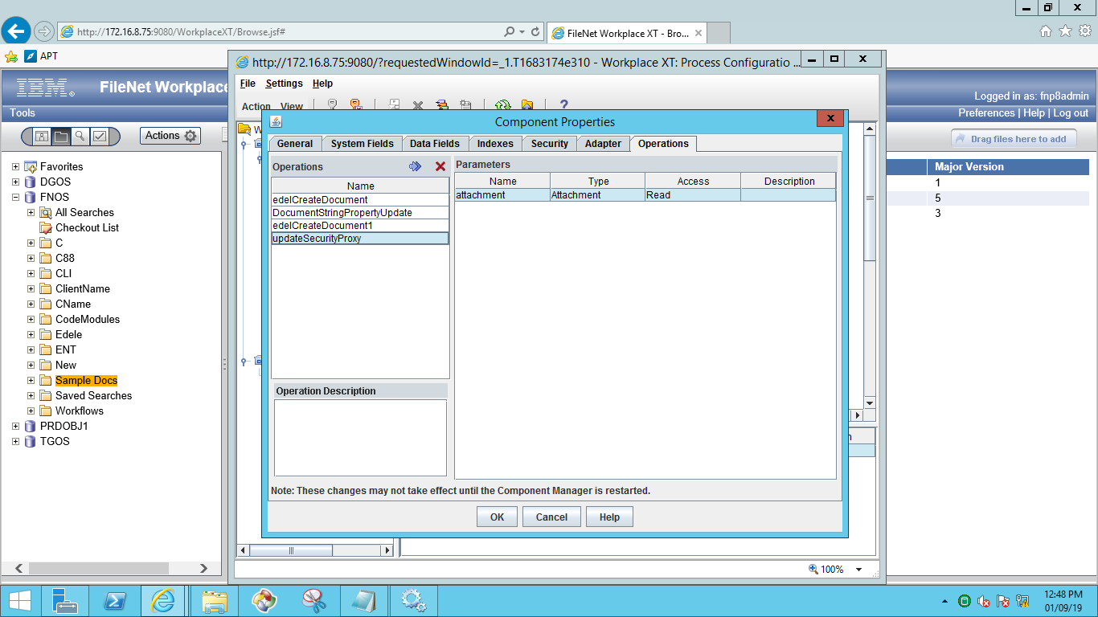

1. UpdateArchivalDateInContentEngine

It helps the system to update Archival date on document once the Archival step is completed.

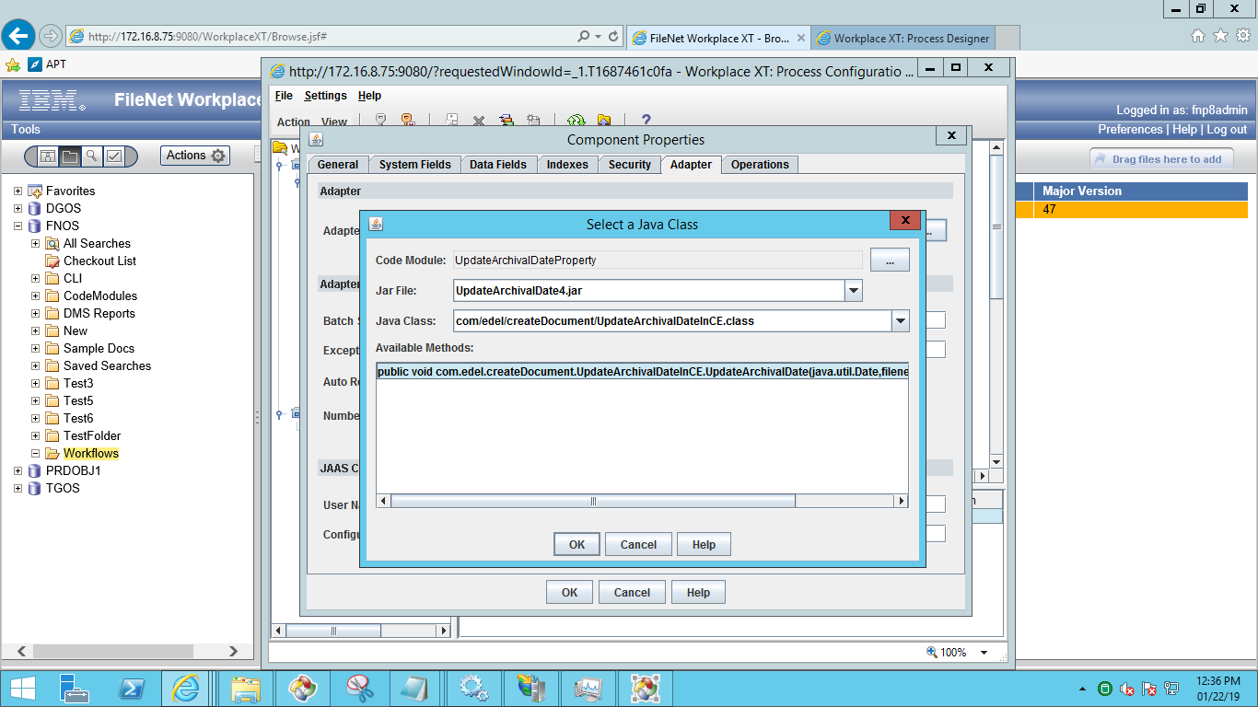

Below are the methods consisting for this component.

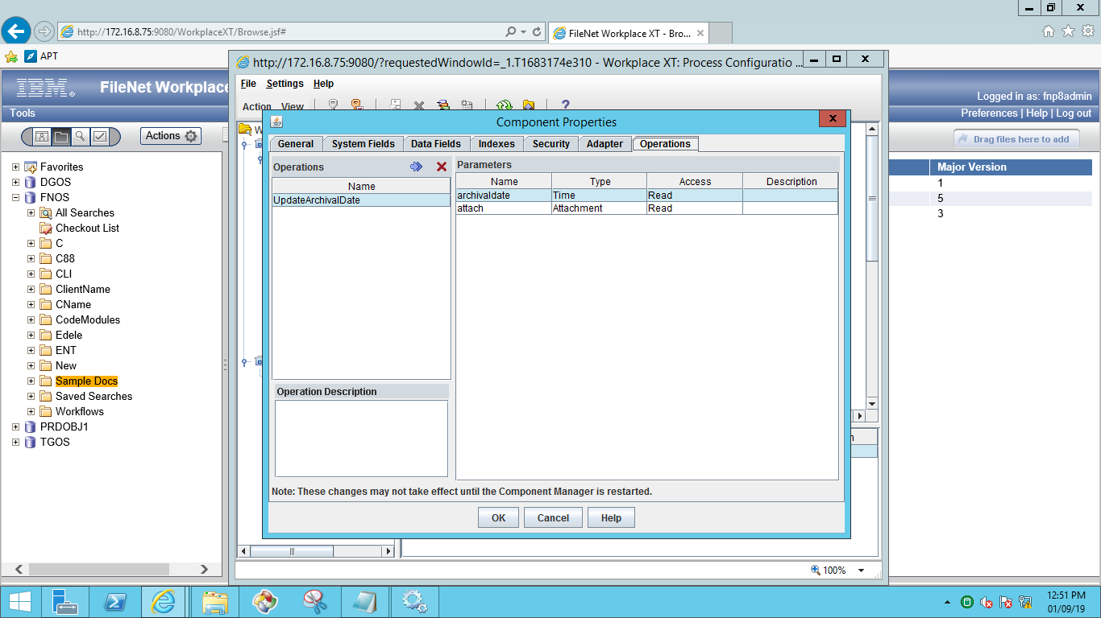

1. UpdateDocumentProperties

This component helps the system to update Dispatch date on Document.

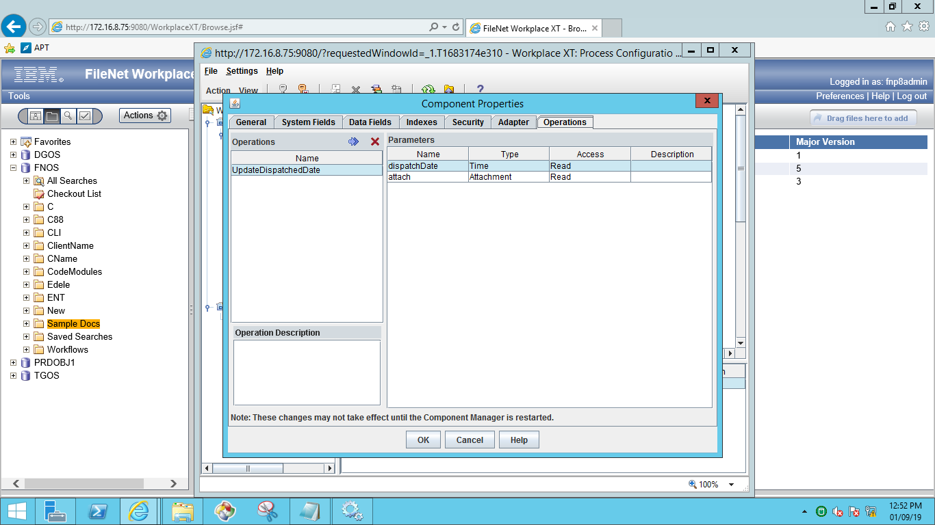

### Property File Path:

Property File Path: C:\Edel\CreateDocument.properties

### In-basket Details.

1. Created In-basket’s for different roles.
   * 1. Processing
     2. Archival
2. Processing step: In-basket name is ‘Processing’ and “Scanning QA” is the Queue name .
3. Dispatch step: In-basket is ’Archival’ and “Archiving” is the Queue name .
4. Archive step: In-basket is ’Archival’ and “Archiving” is the Queue name .

**Note**: Same In-basket and Same Queue used for above two –steps.

### Work Queues

Create below Work queues and Inbaskets.

* Archiving
* ScanningQA

**Procedure to create work queues:**

Open WorkplaceXT and go to process configuration console and select **work queue** to create new one.

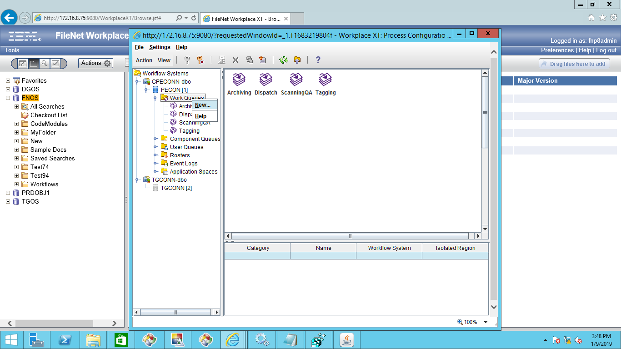

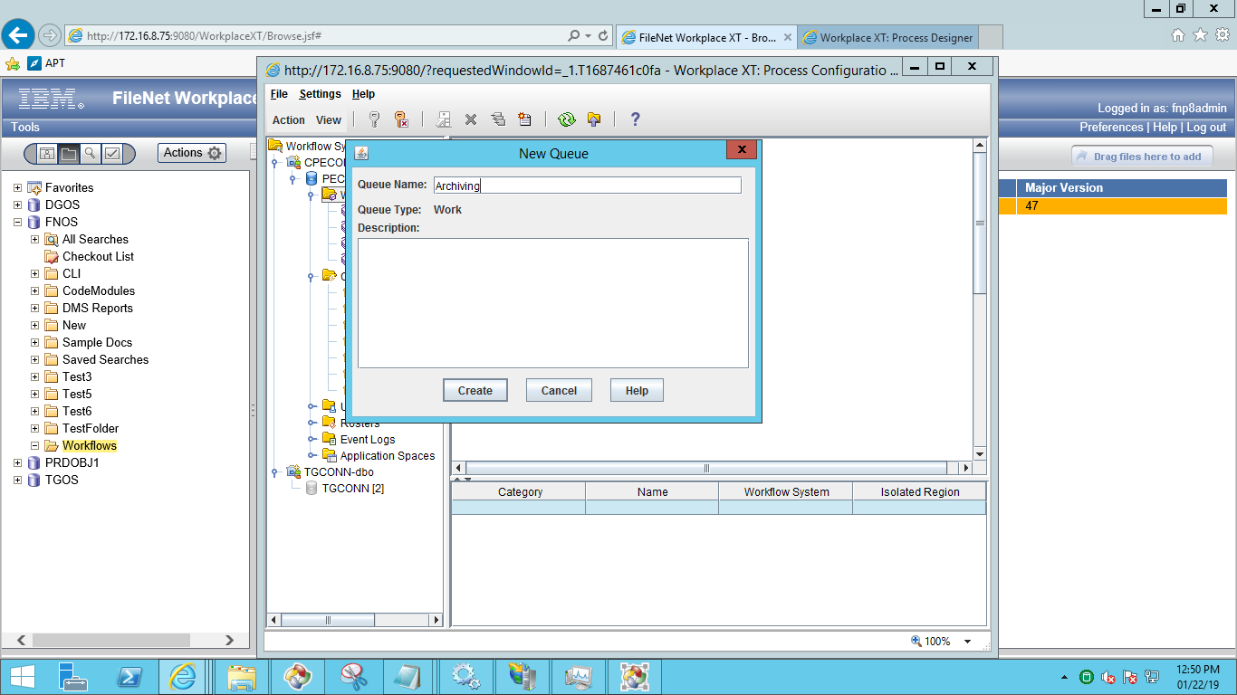

After creation of work queue ,go to data fields and add required fields as below,

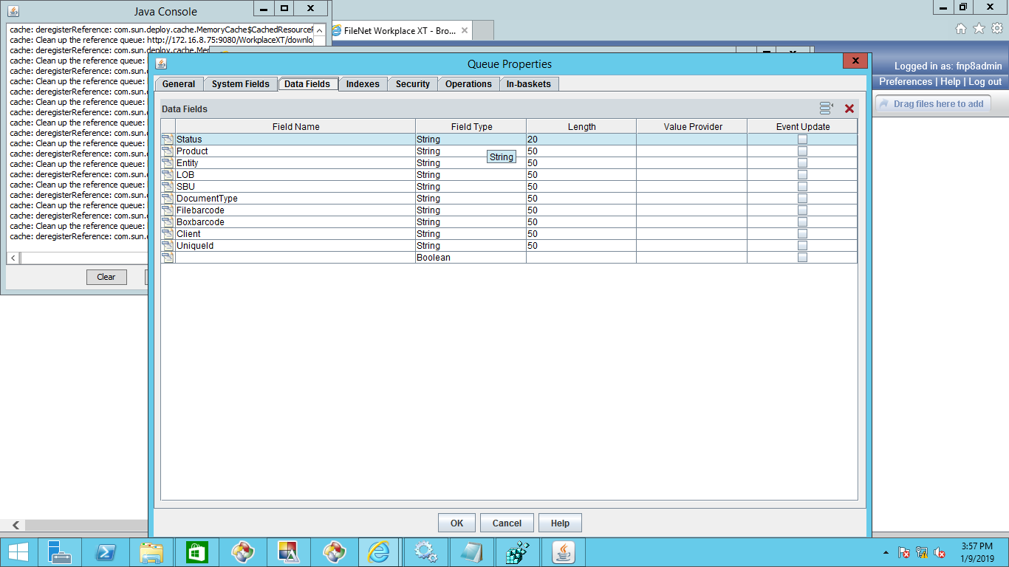

After adding the data fields click on inbasket and create inbasket and add the data fields as shown in below screen.

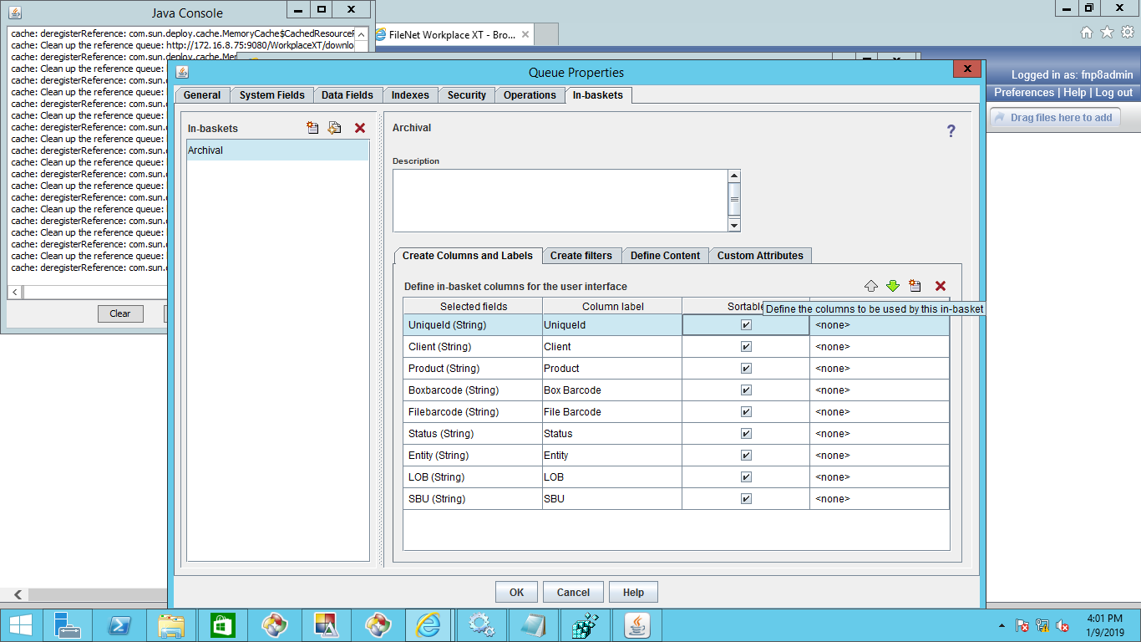

Same procedure for both the work queues.

### In-baskets

Below are the In-baskets for roles.

* Processing
* Archival

Open WorkplaceXT and select work queue and click on properties and choose Inbasket tab as shown in the below screen. Here add all the properties required for the inbasket.

For **ScanningQA** work queue **Processing** is the Inbasket name.

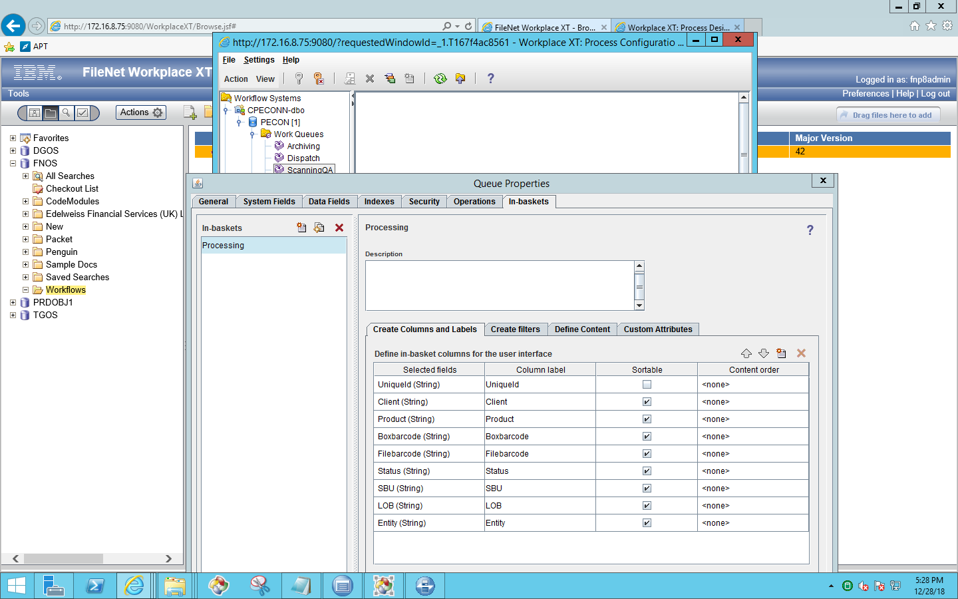

For **Archiving** work queue **Archival** is the Inbasket name.

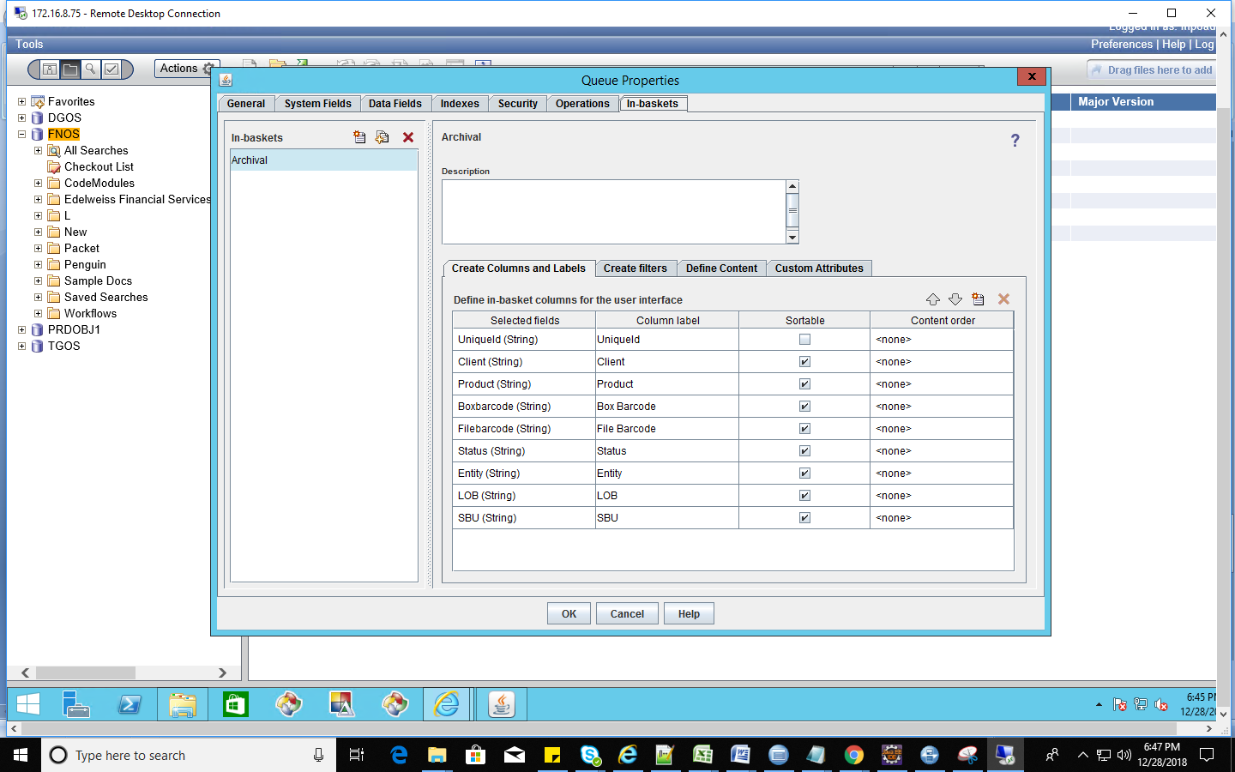

### Roles

Below are the two roles used.

* Archival
* Processing

Open WorkplaceXT and go to Process configuration console the below screen will appear.

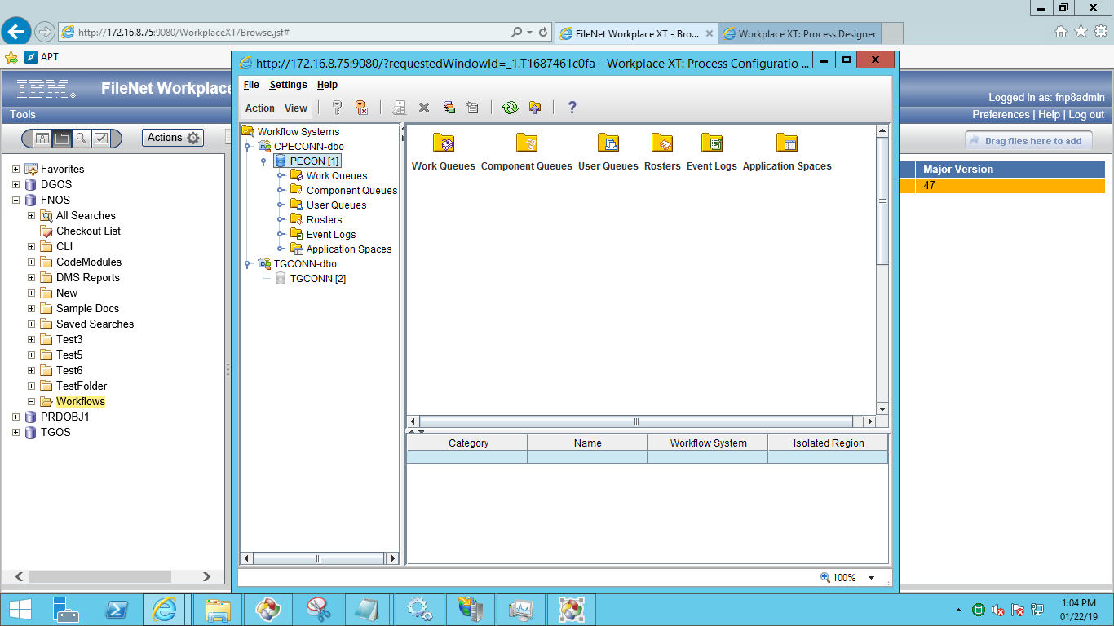

Here select application space folder and select application space and go to the properties of the application space.

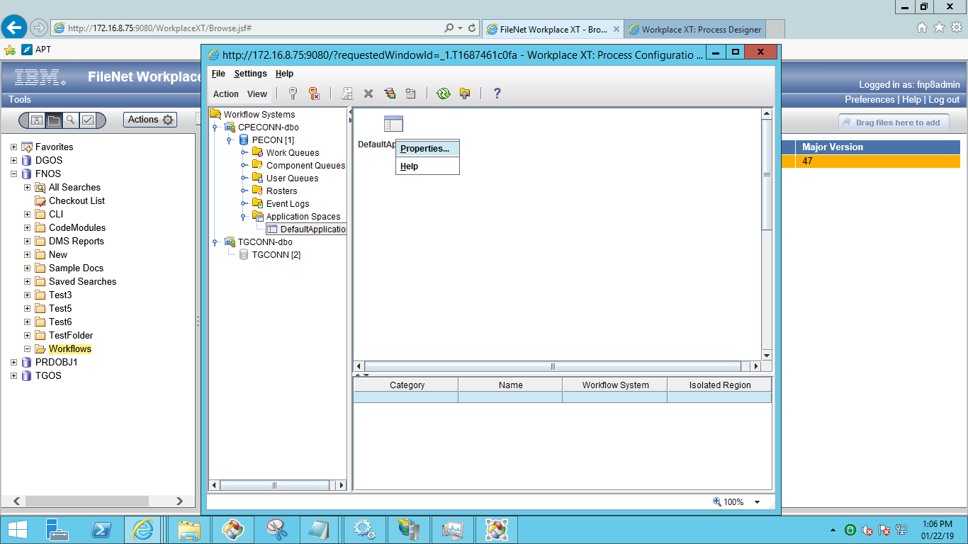

After clicking on properties below screen will appear. Click on Roles tab and select Inbaskets and add the users for the Inbasket as shown in the below screen.

Below screens helps for names of the Roles and Inbaskets names as well.

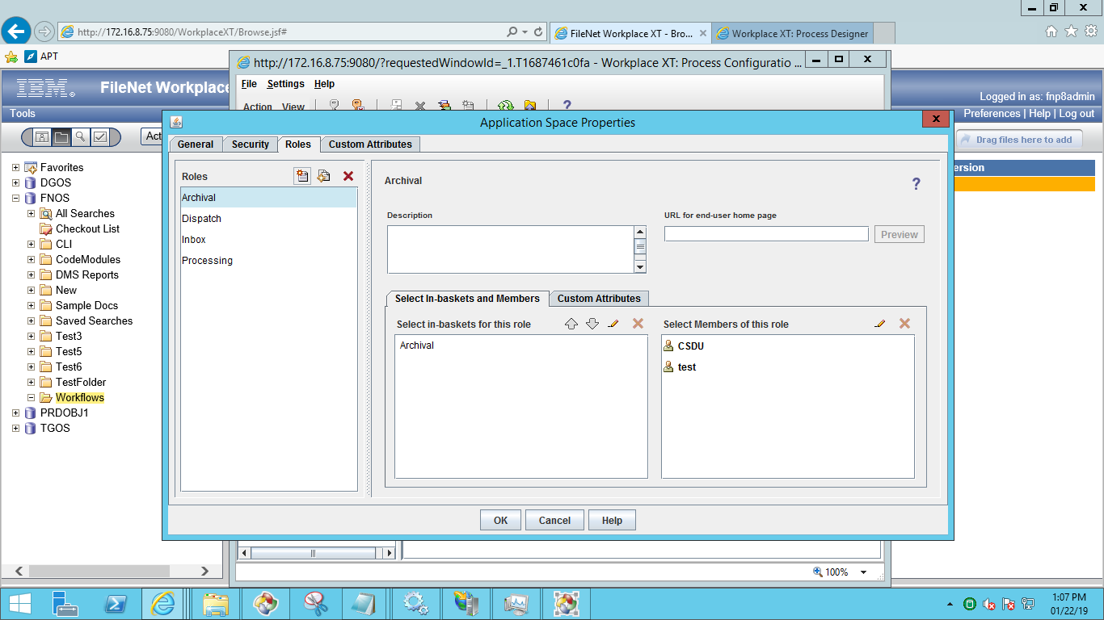

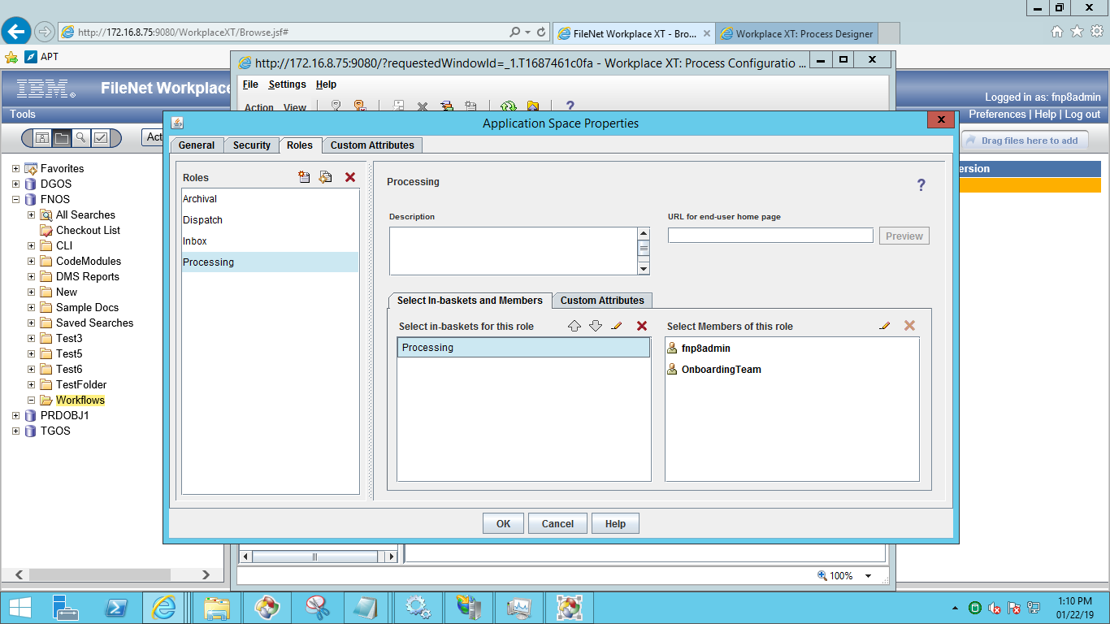

## Security Proxy

Create Proxy Class in Custom Object

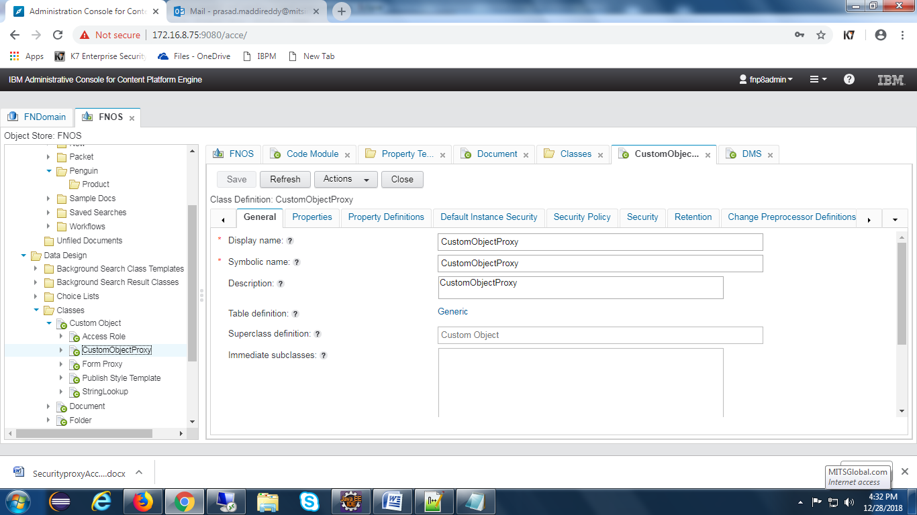

Create proxy property

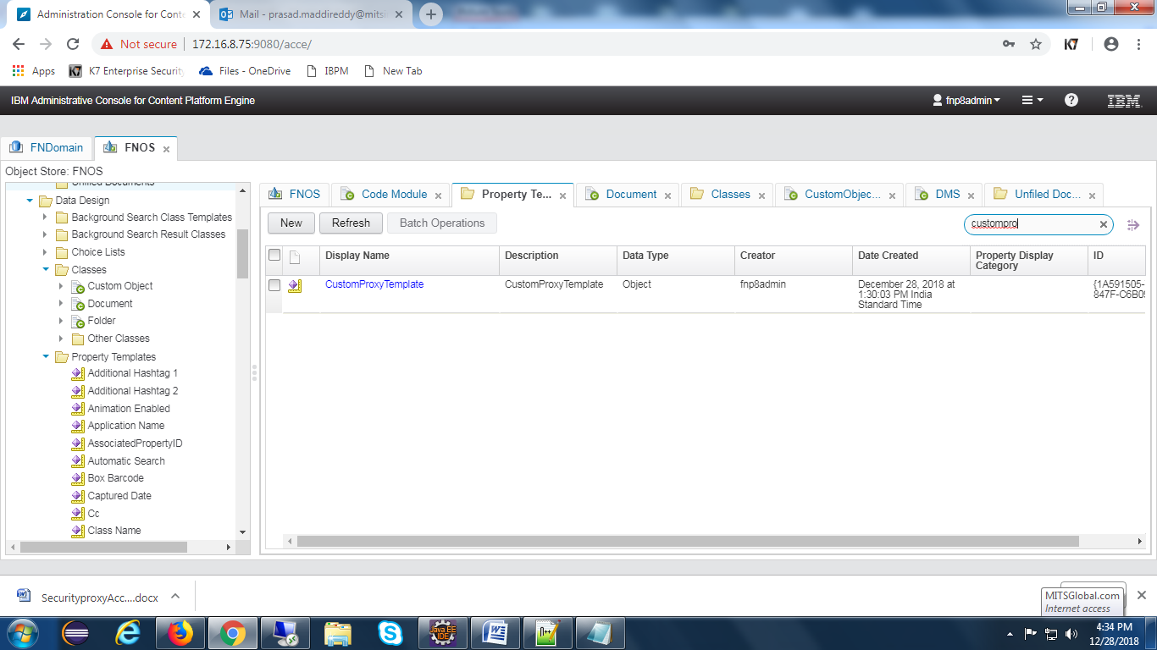

Add property to folder class

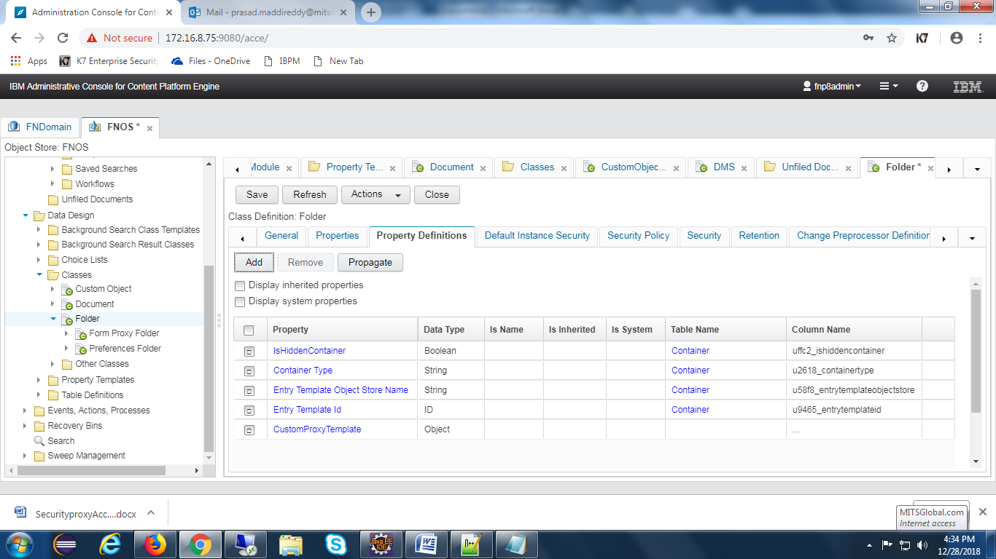

Set class type as CustomObjectProxy to the property

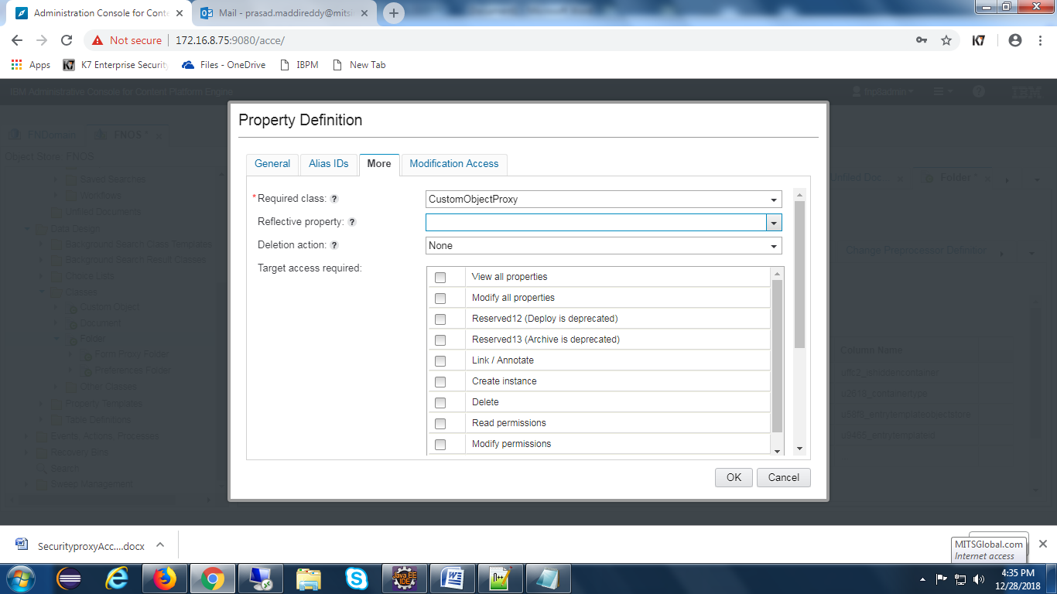

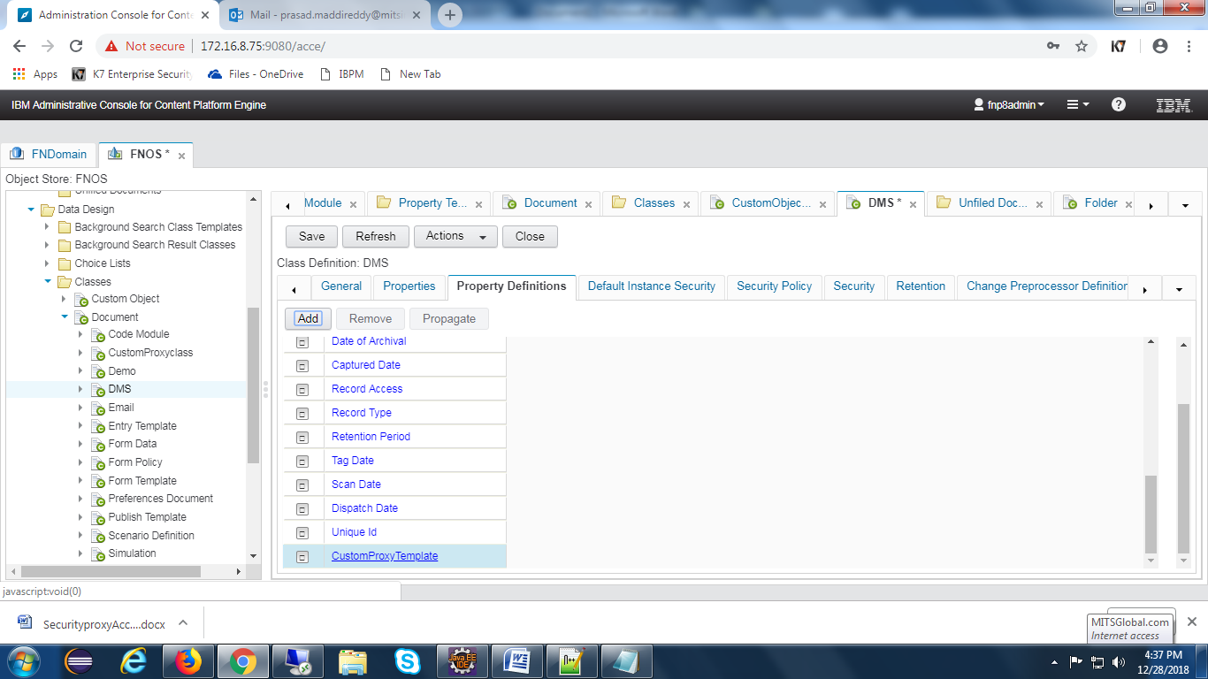

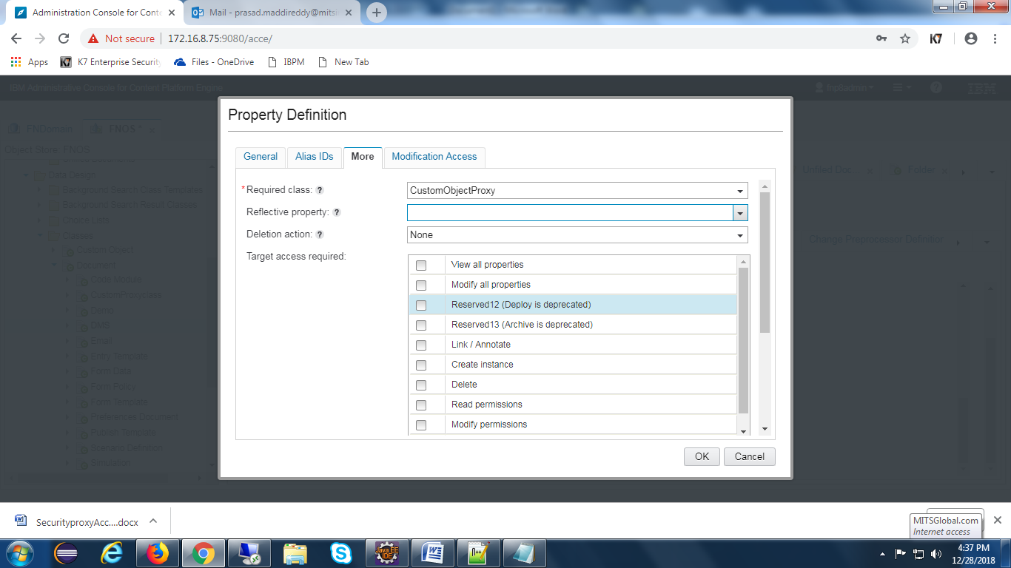

Create two proxies for document and folders

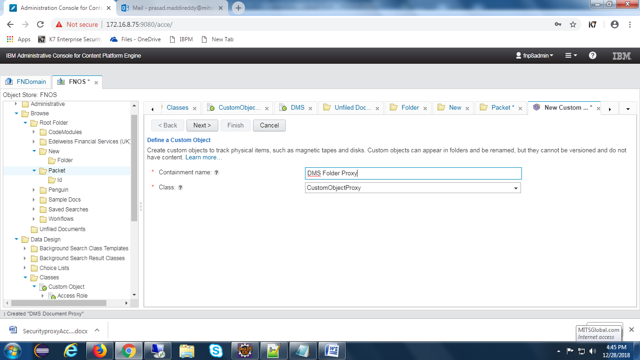

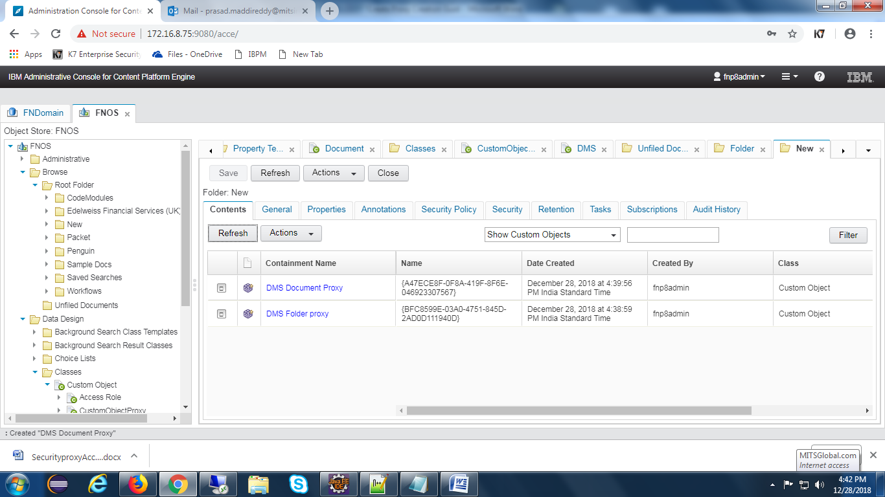

## Workflow Subscription

**Create Event action:-**

Open acce and select event actions tab to create event action.

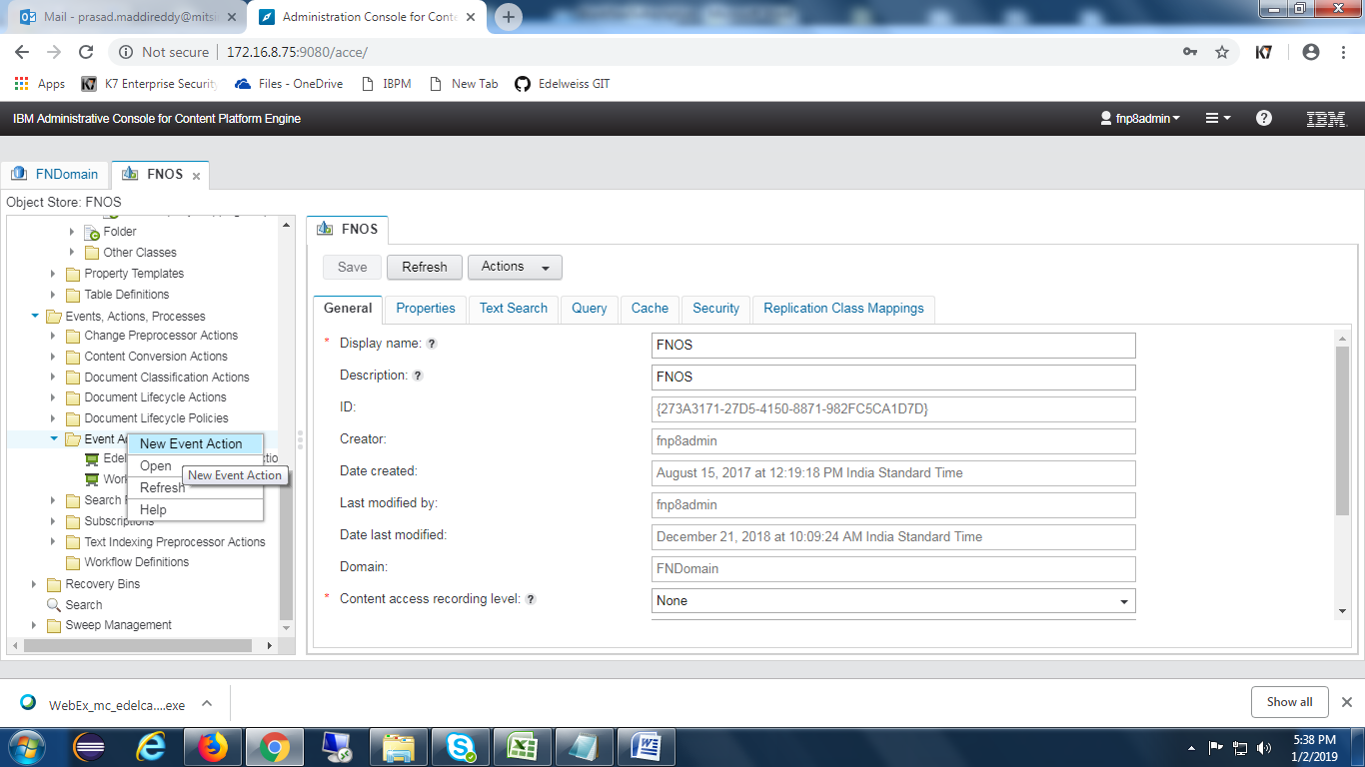

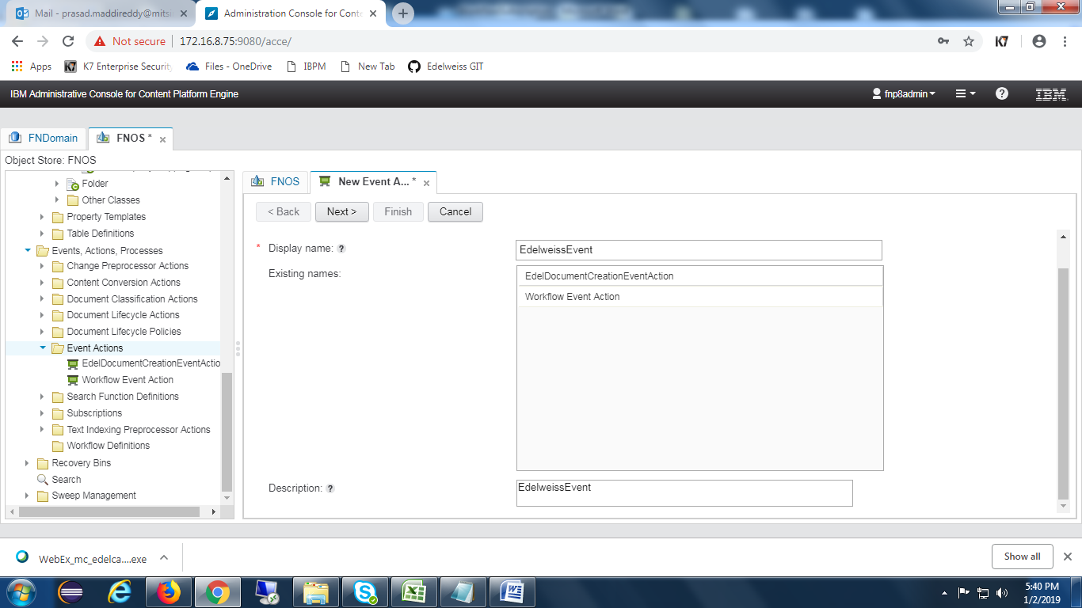

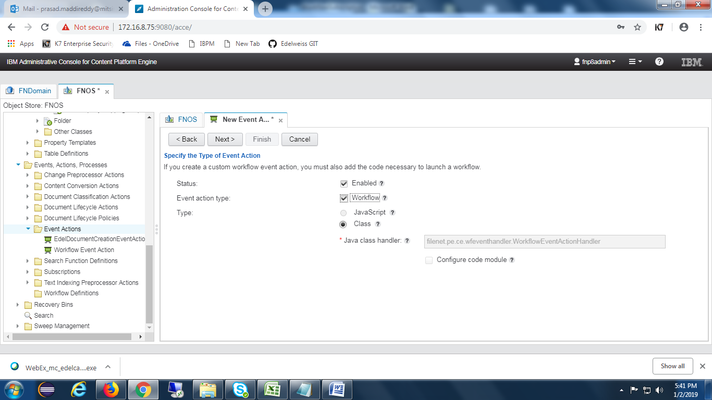

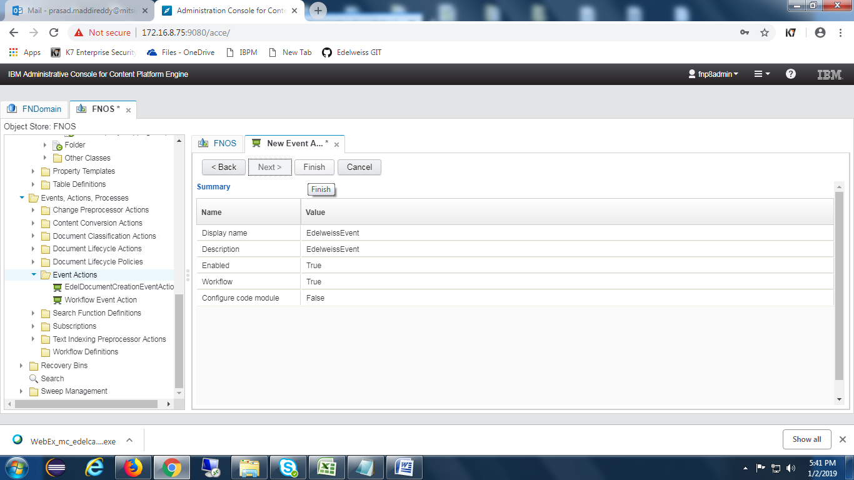

**Create Subscription:-**

Select the required class to create subscription. Once selecting the class , choose subscription button as shown in the below screen.

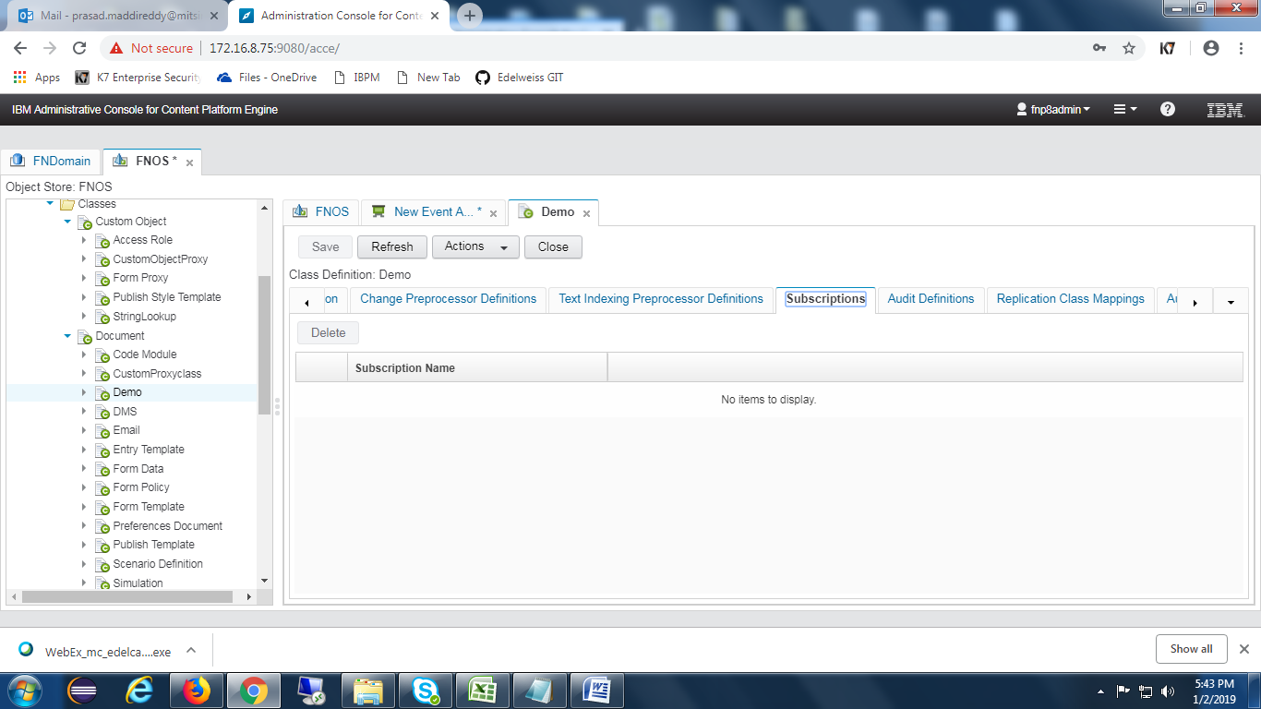

Click on **Actions** and select New subscription as below.

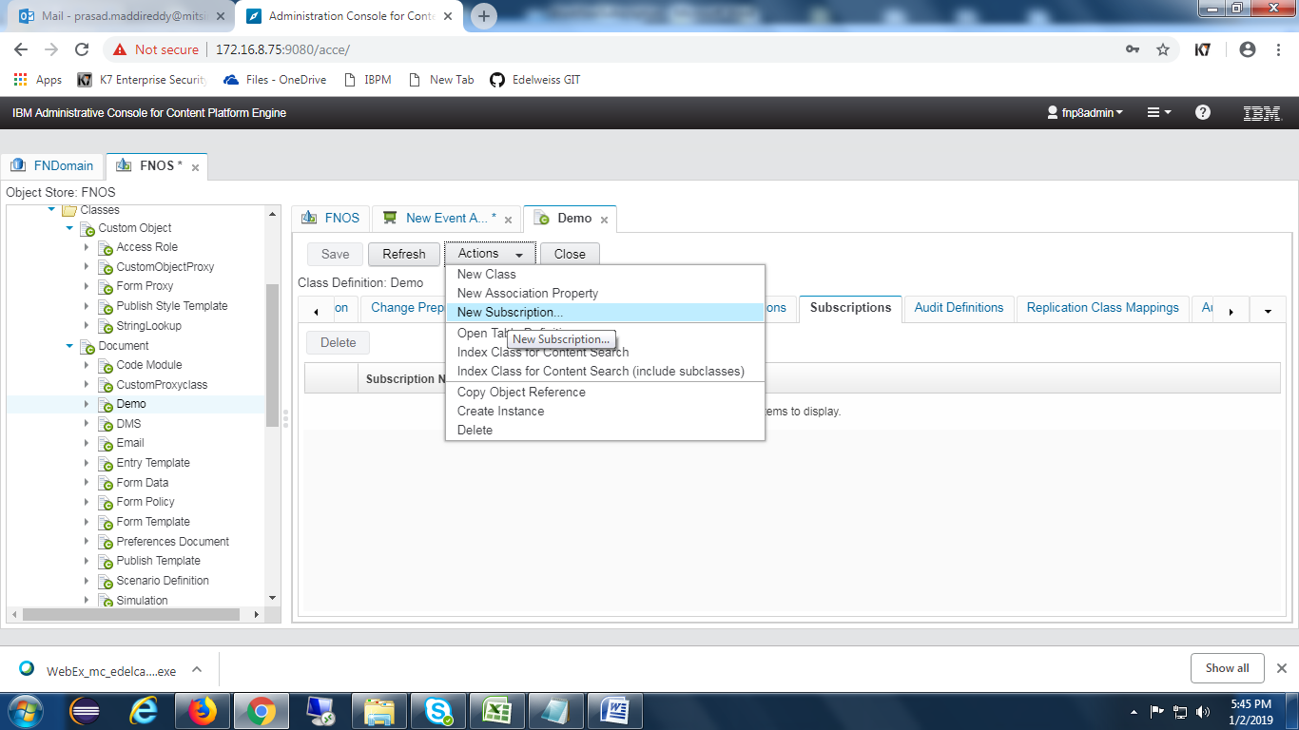

Give name for the subscription.

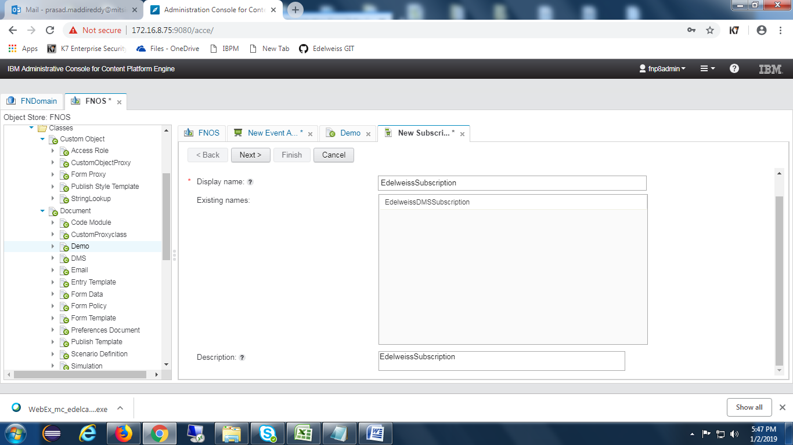

Select **Create a workflow subscription** checkbox as shown in the below screen.

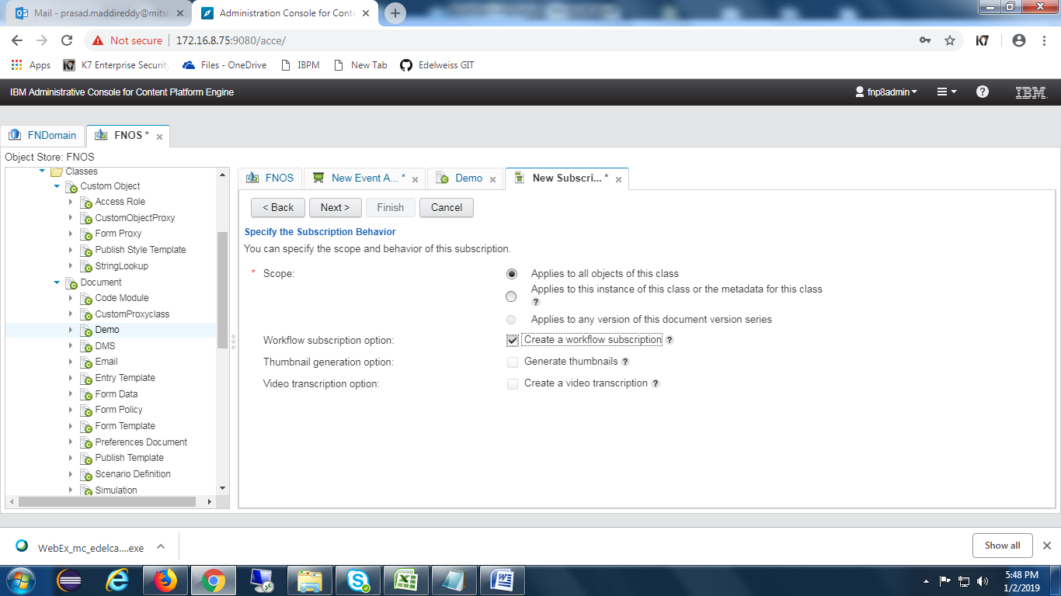

Choose appropriate **Event(Creation Event)**

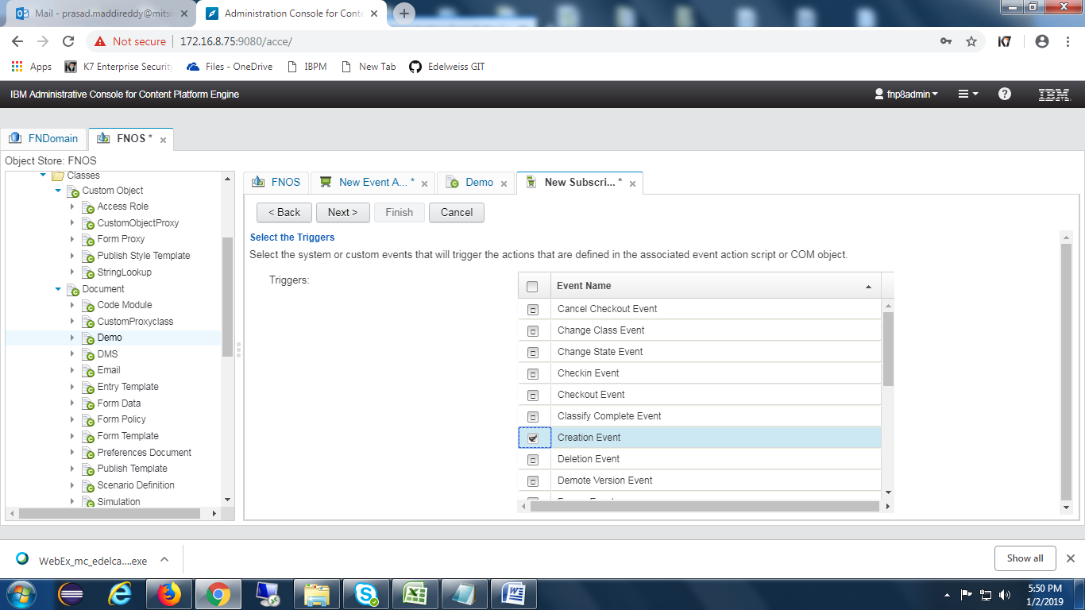

Choose the **event action** which was created earlier.

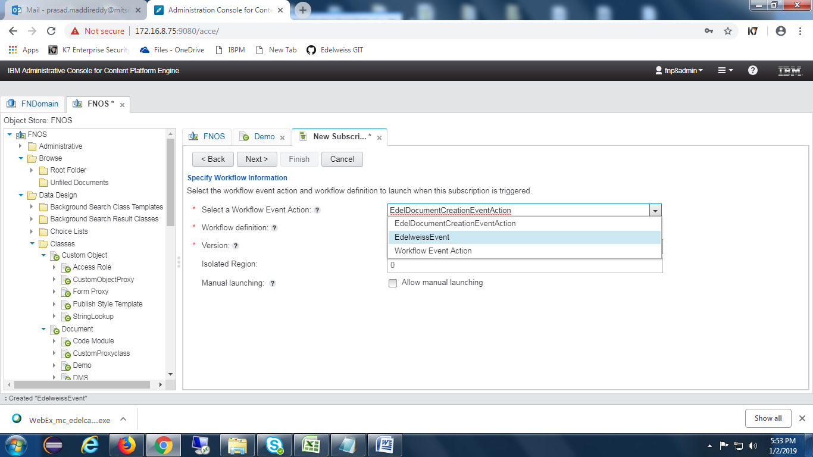

Choose the **Workflow** shown in the drop down.

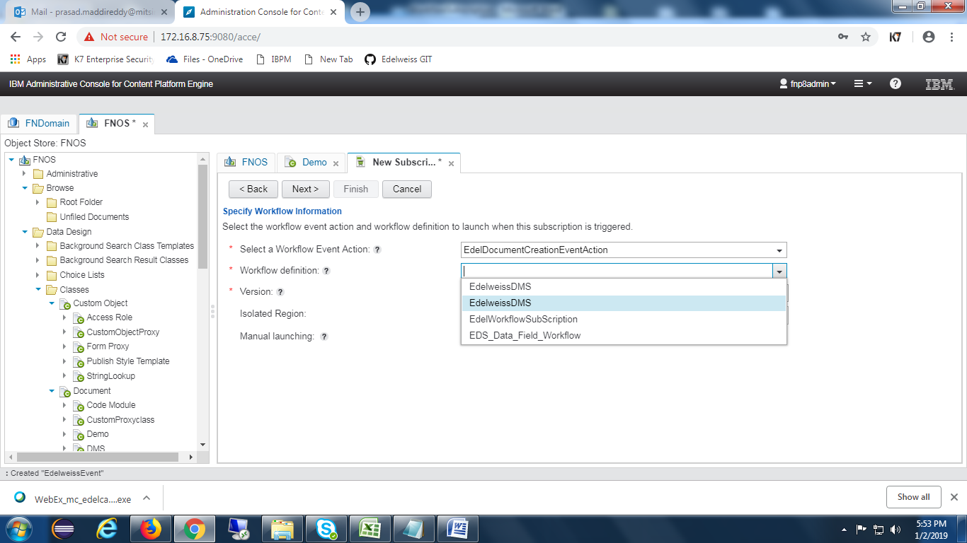

Map Workflow properties with the CE properties as below

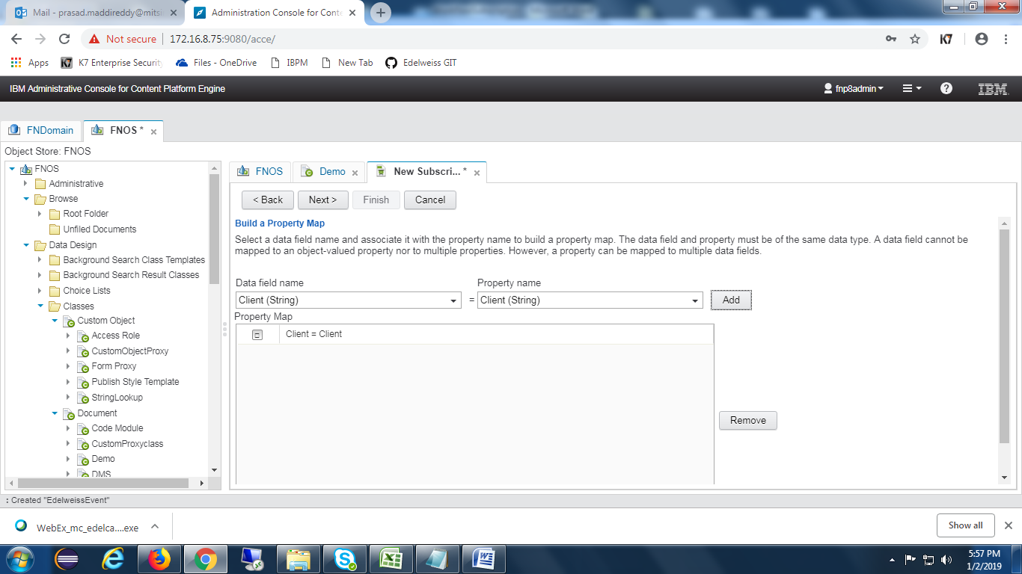

Click on **Next** button as shown in the below screen.

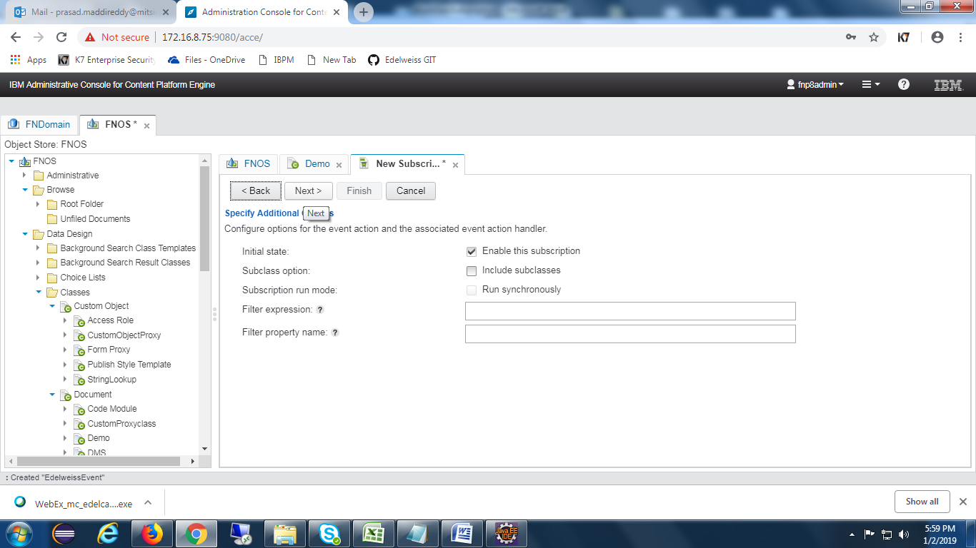

Press on **Finish** button as well.

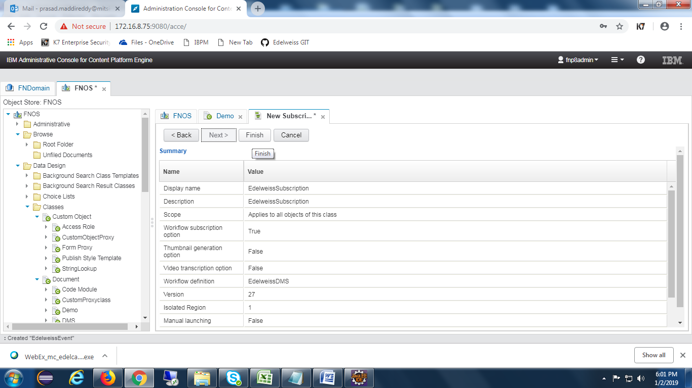

Open the subscription and Click on Configuration and add filter expression as below.

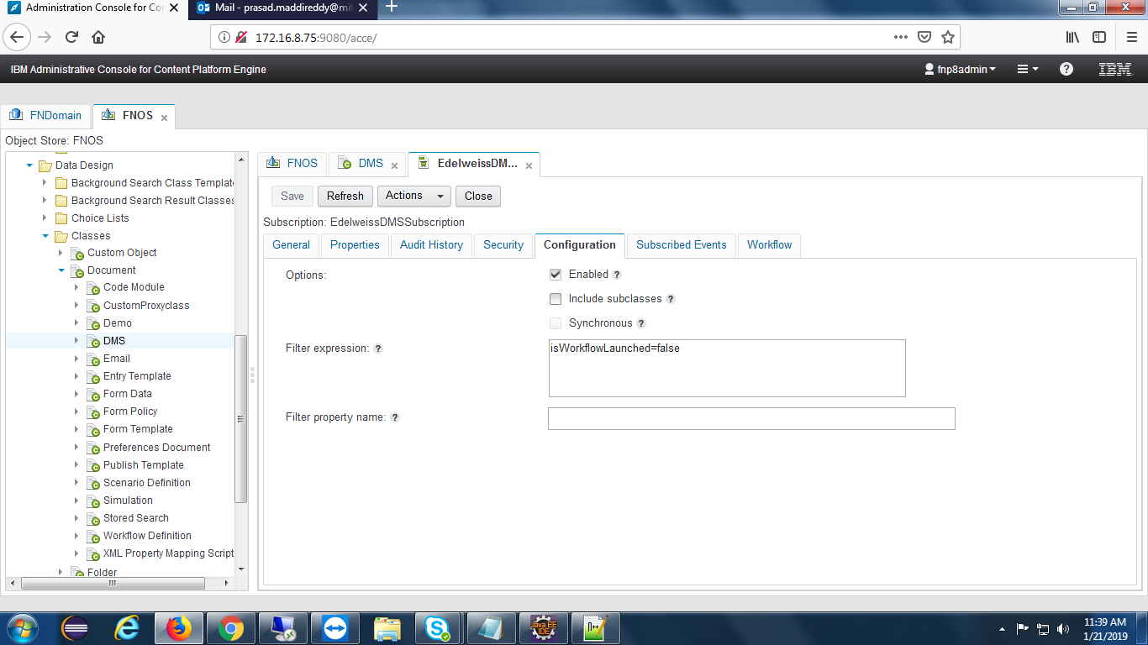

## CE Properties

Below are the symbolic names of the property templates.

I. AdditionalHashtag1(String)

II. AdditionalHashtag2(String)

III. BoxBarcode(String)

IV. CapturedDate(Date Time)

V. Client(String)

VI .CustomProxyTemplate(Object)

VII. DateofArchival(Date Time)

VIII. DispatchDate(Date Time)

IX. DMPartner(String)

X. DocumentType(String)

XI. Entity(String)

XII. FileBarcode(String)

XIII. isWorkflowLaunched(Boolean)

XIV. LOB(String)

XV. Product(String)

XVI. RecordAccess(String)

XVII. RecordClassification(String)

XVIII. RecordName(String)

XIX. RecordType(String)

XX. RetentionPeriod(String)

XXI. SBU(String)

XXII. ScanDate(Date Time)

XXIII. Stage(String)

XXIV. Status(String)

XXV. TagDate(Date Time)

XXVI. UniqueId(String)

## Desktop Creation

Open navigator and select **Open administration view** feature. Select **new desktop** button and it will show below screen.

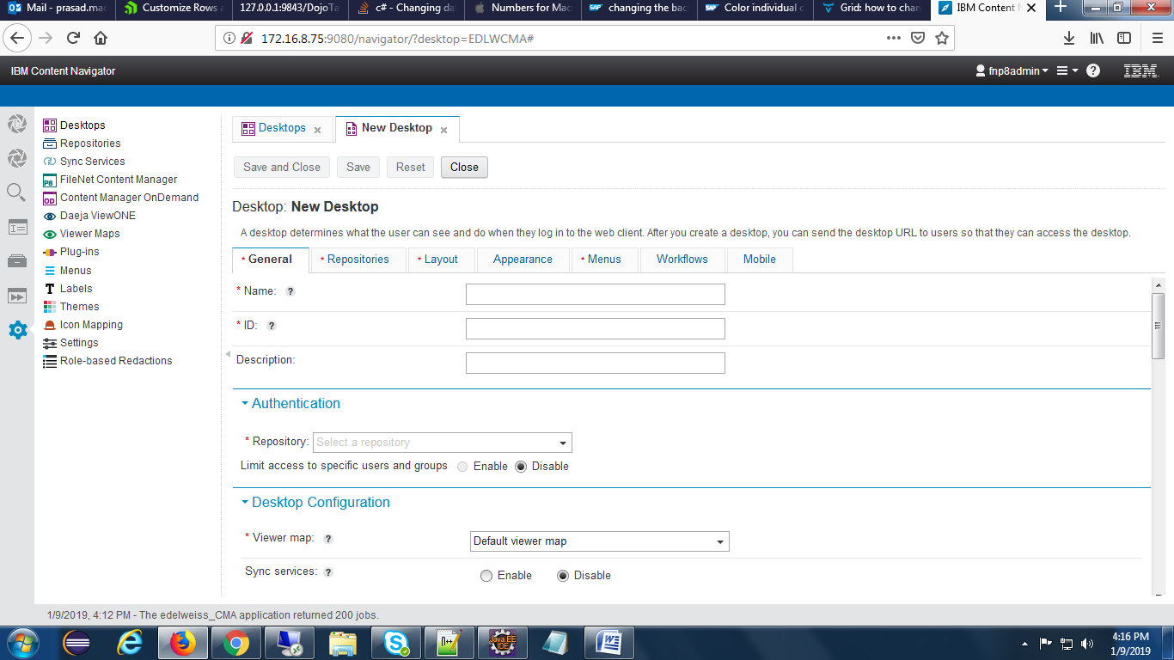

Provide desktop Name and Id and Description and select appropriate repository in the drop down of repository.

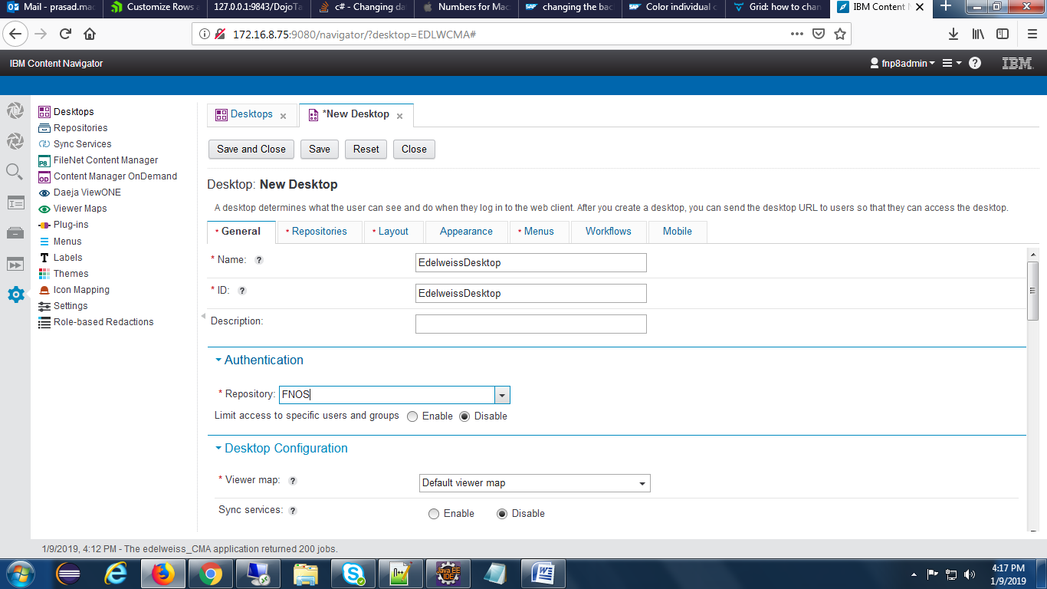

select repositories tab and choose the repository as below.

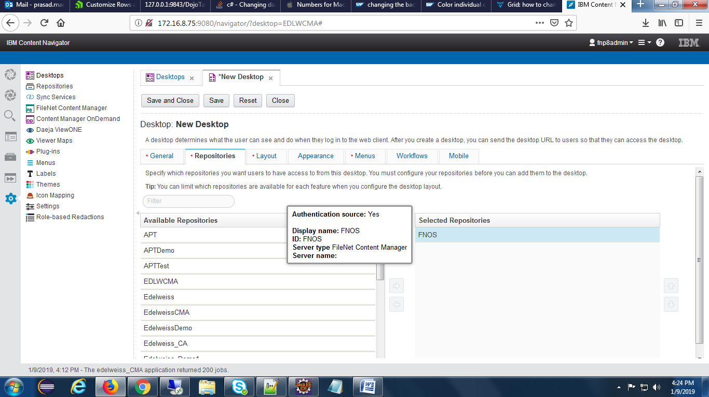

## Reports

**2.8.1** Reports please configure the below steps

Workflow Data Fields add ‘Processcompletedate’.

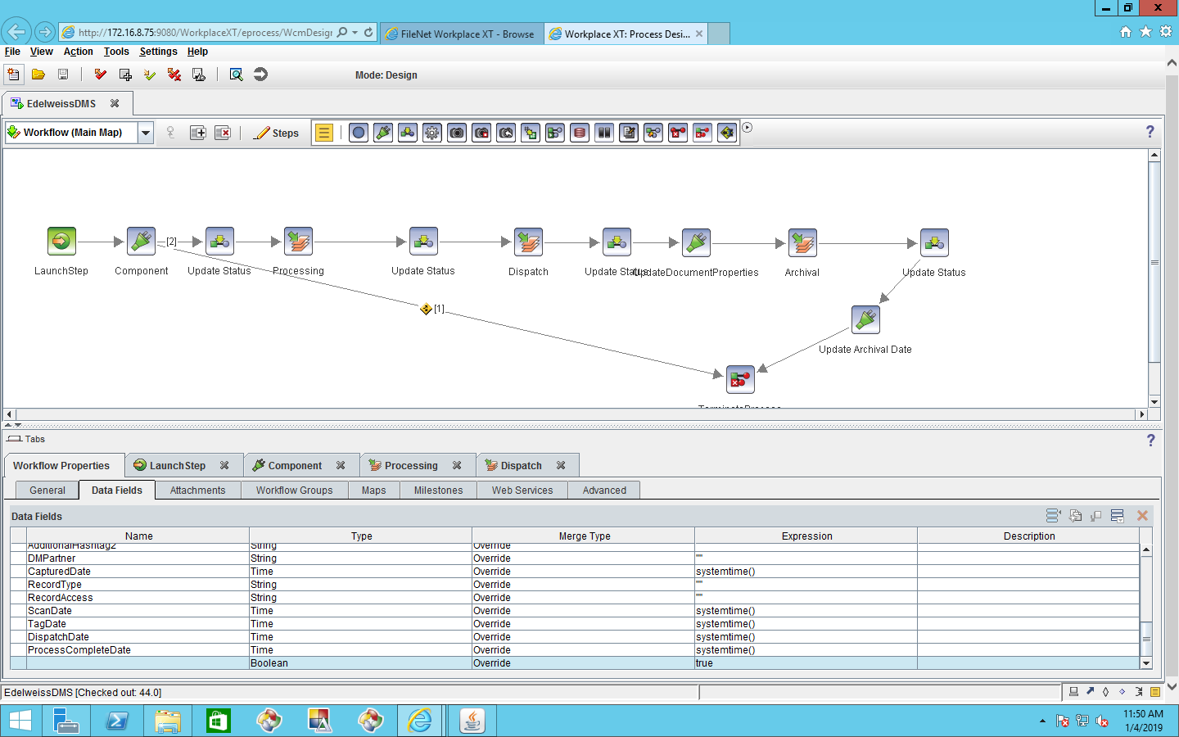

2.8.2 Above create field add to “Processing” step Click on “Assignments” and click on “AfterCompletion”.

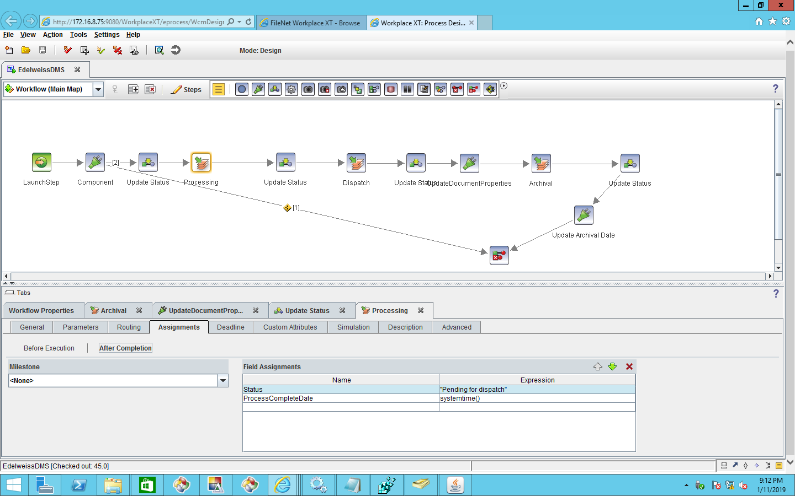

2.8.3 In “ACCE” need to create ‘[ProcessCompleteDate](javascript:void(0))’ Property and update the workflow version and subscription, in fields with workflow fields([ProcessCompleteDate](javascript:void(0))=[ProcessCompleteDate](javascript:void(0))’) also TagDate,ScanDate need to add subscription for reports.

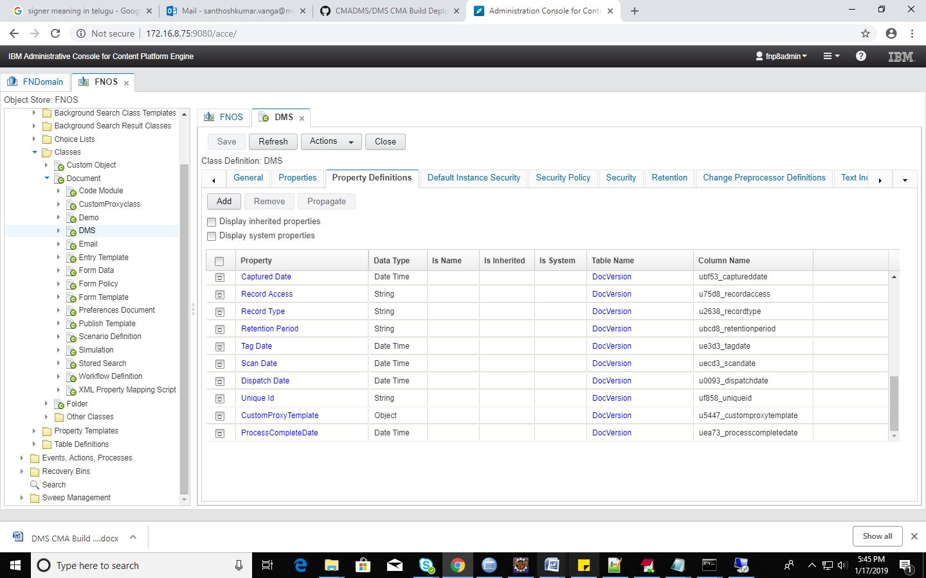

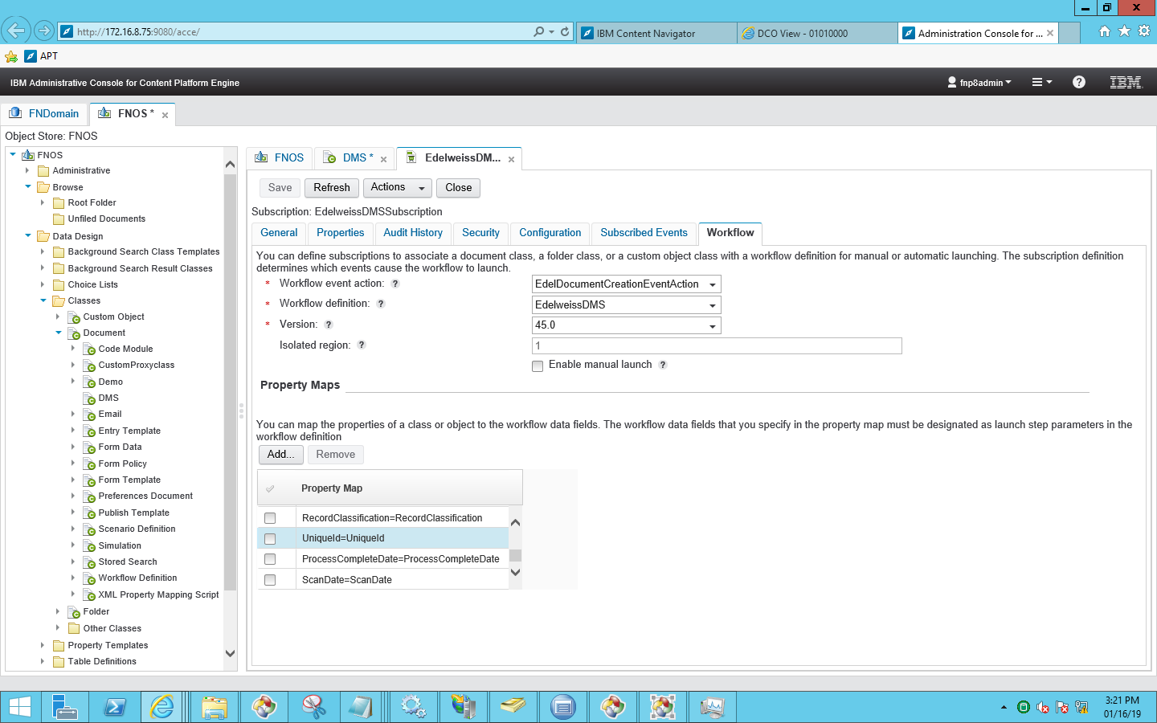

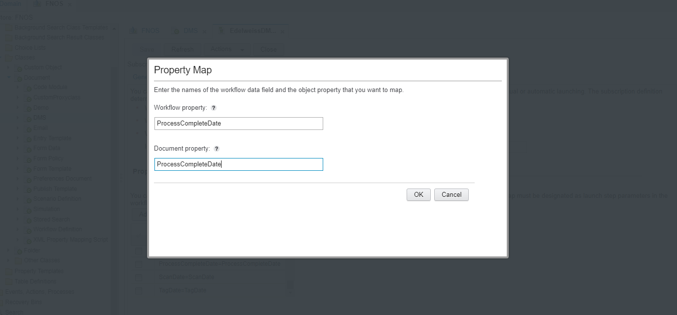



For “event log query “need to expose the fields in “DefaultEventlog “

Open “DefaultEventLog” and expose below fields.

